**A. ACE2-derived control peptide B. Peptide 7ls9_C_E_3867**

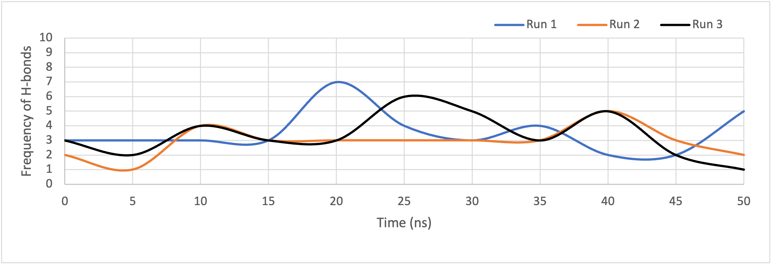 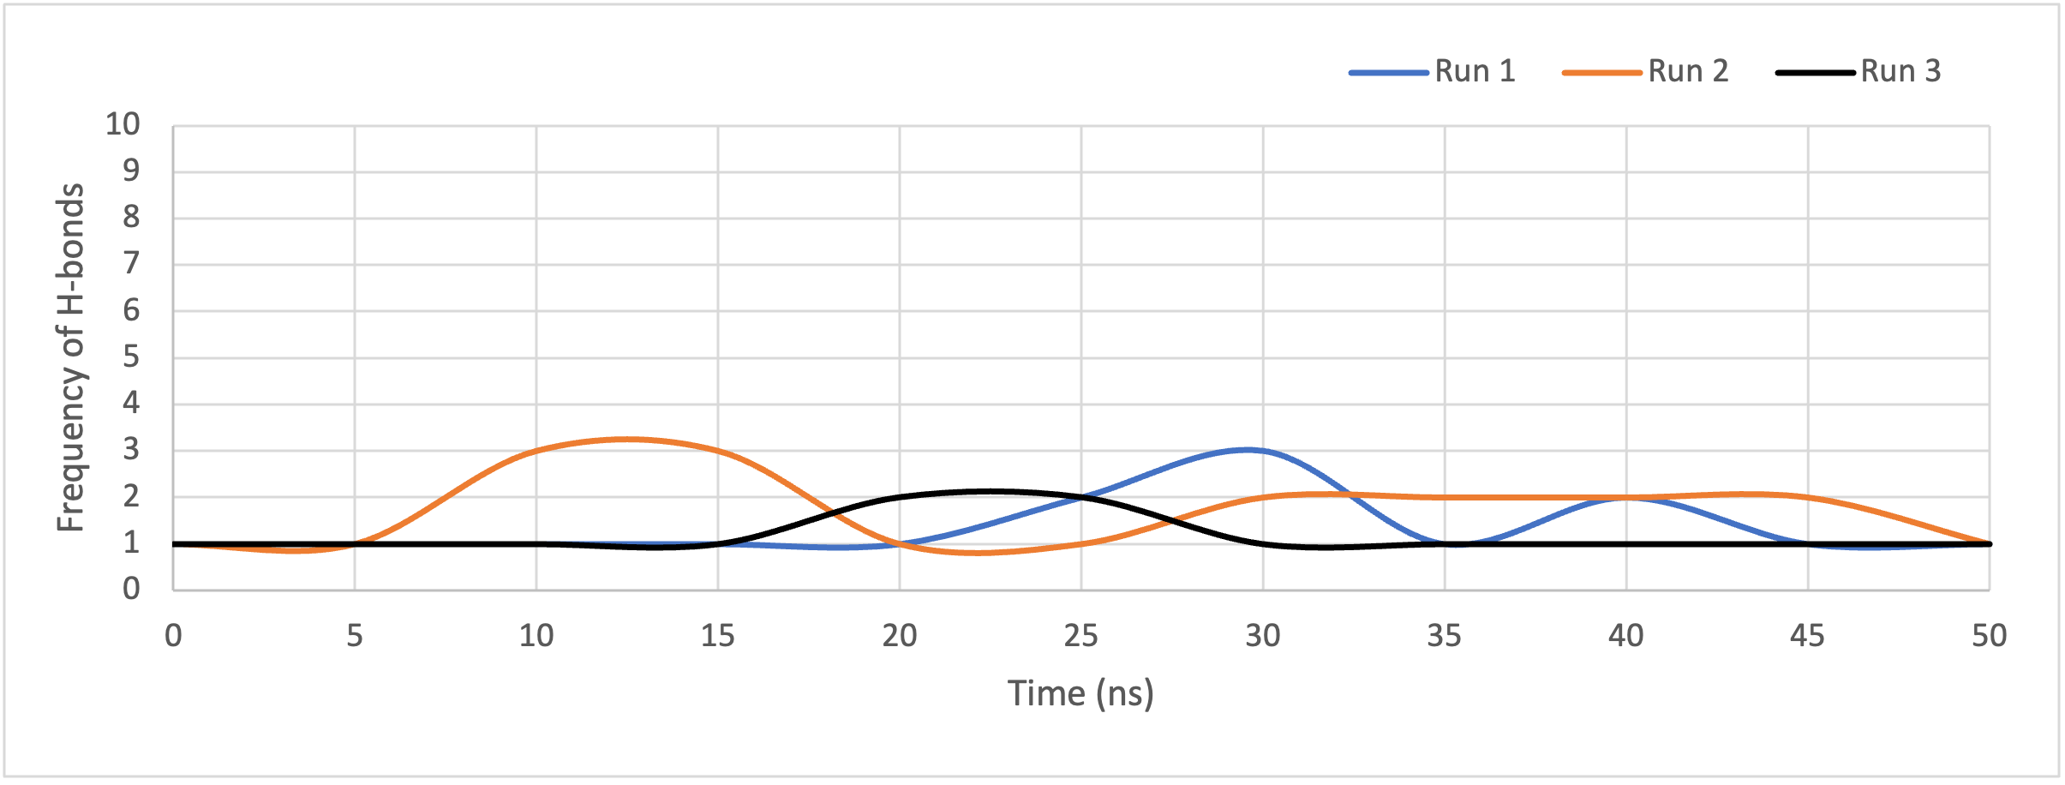

**C. Peptide 6xkp_B_M_919 D. Peptide 7kn5_B_D_619**

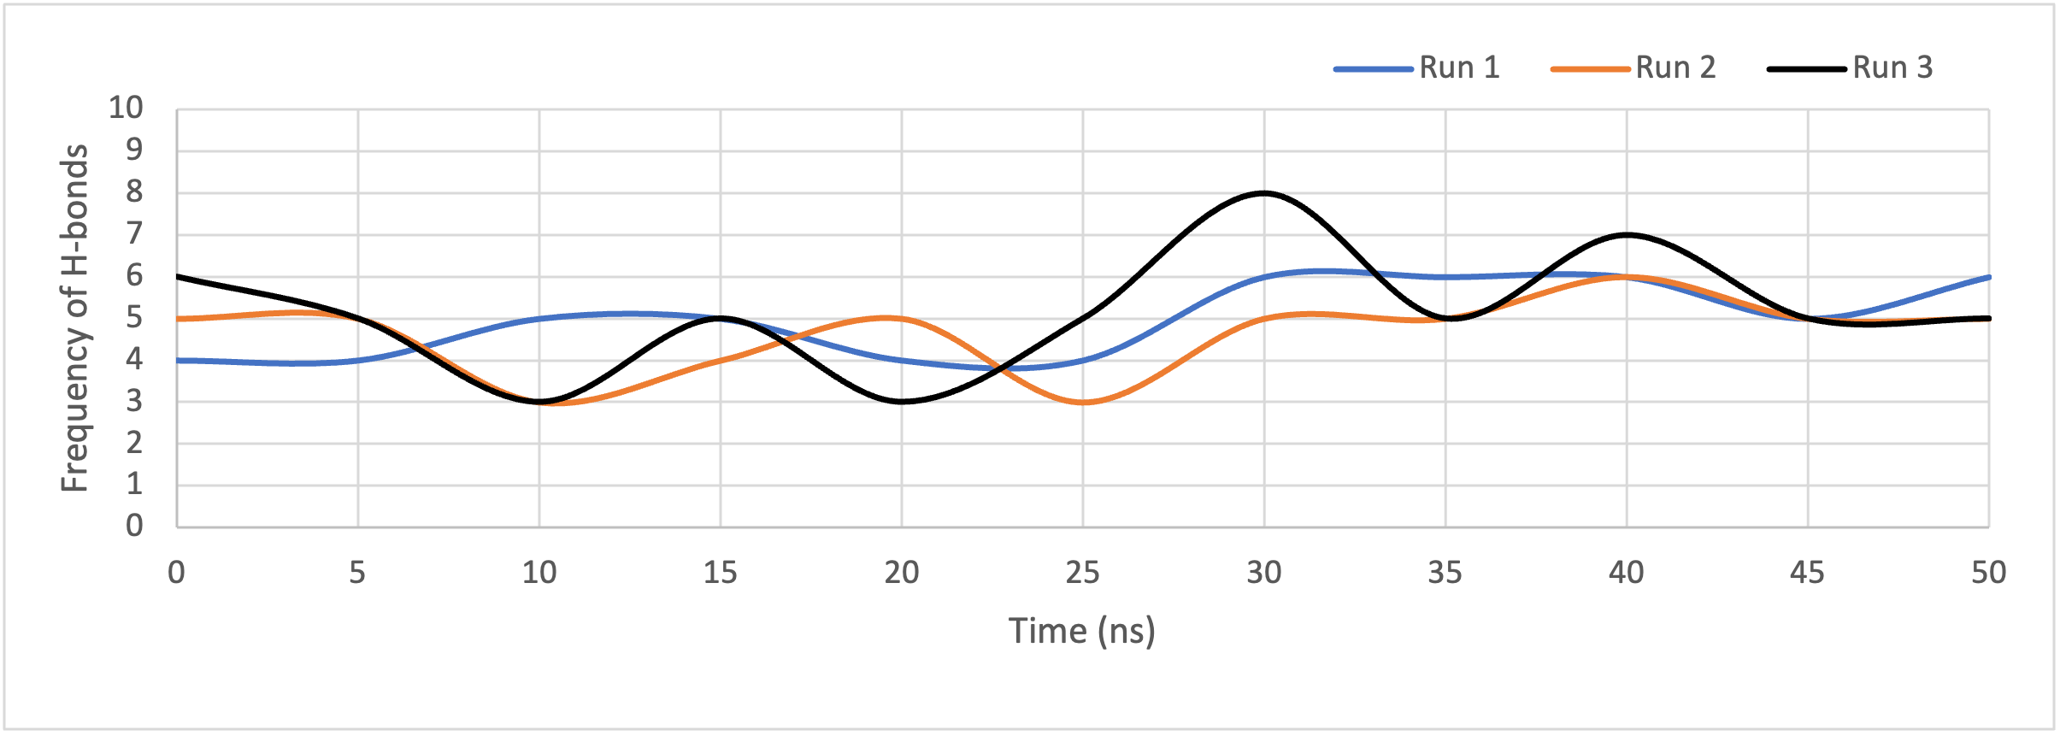 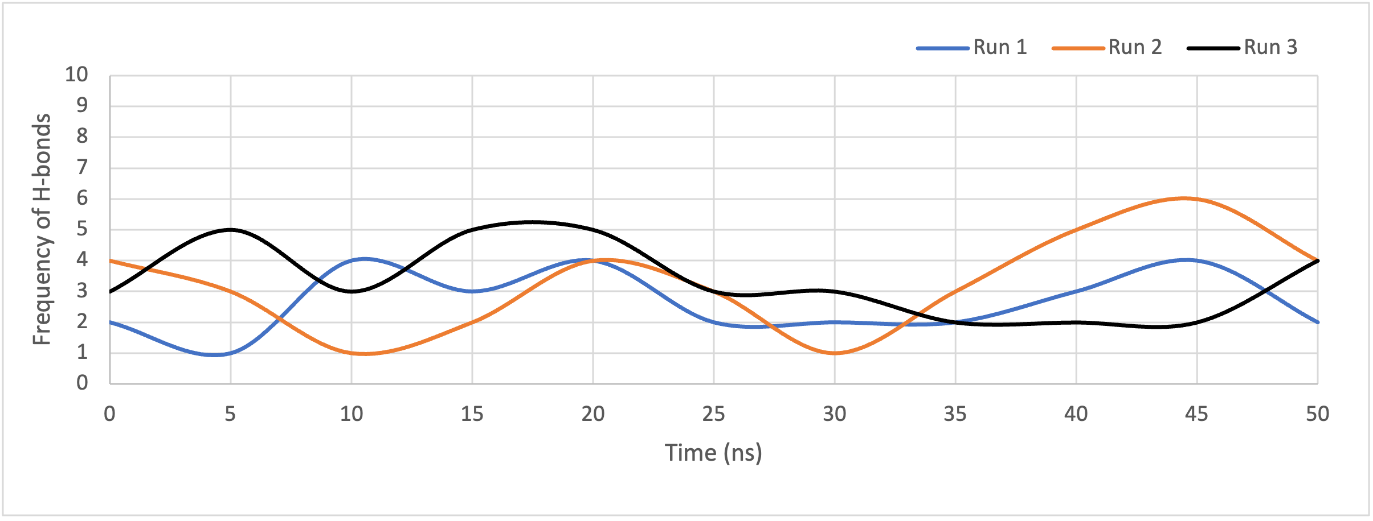

**E. Peptide 7m7w_S_C_752 F. Peptide 7kmg_C_A_47**

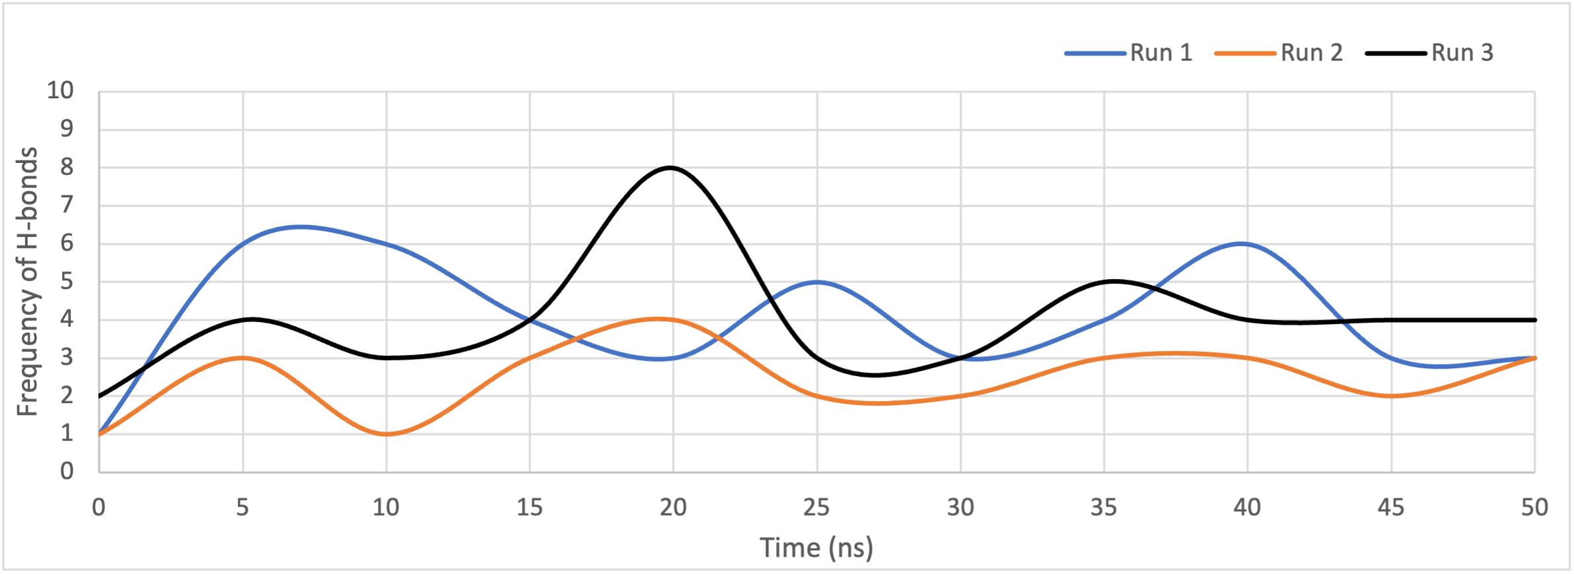 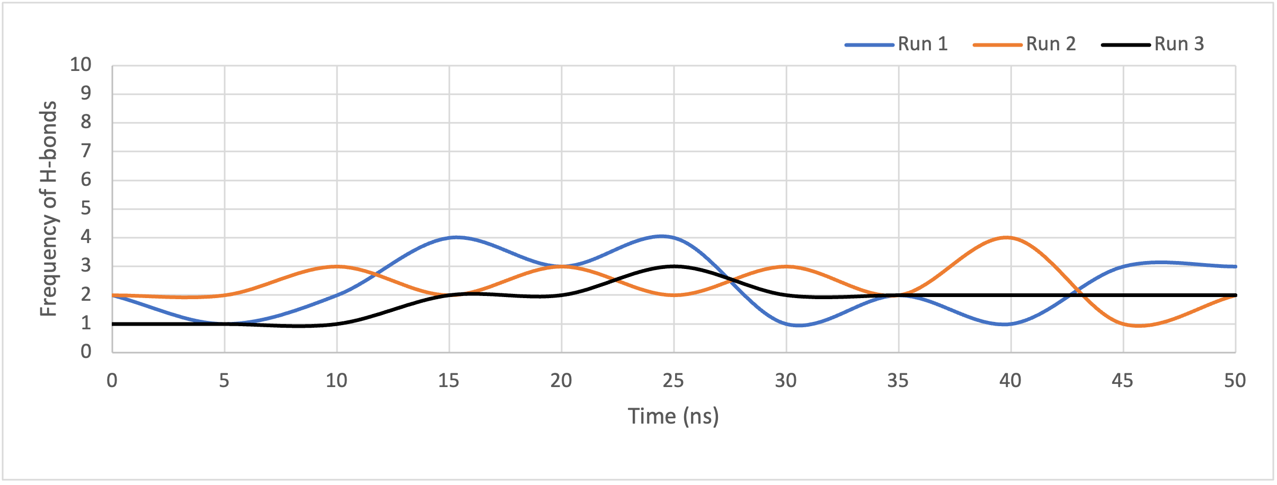

**G. Peptide 7l0n_R_A_312**

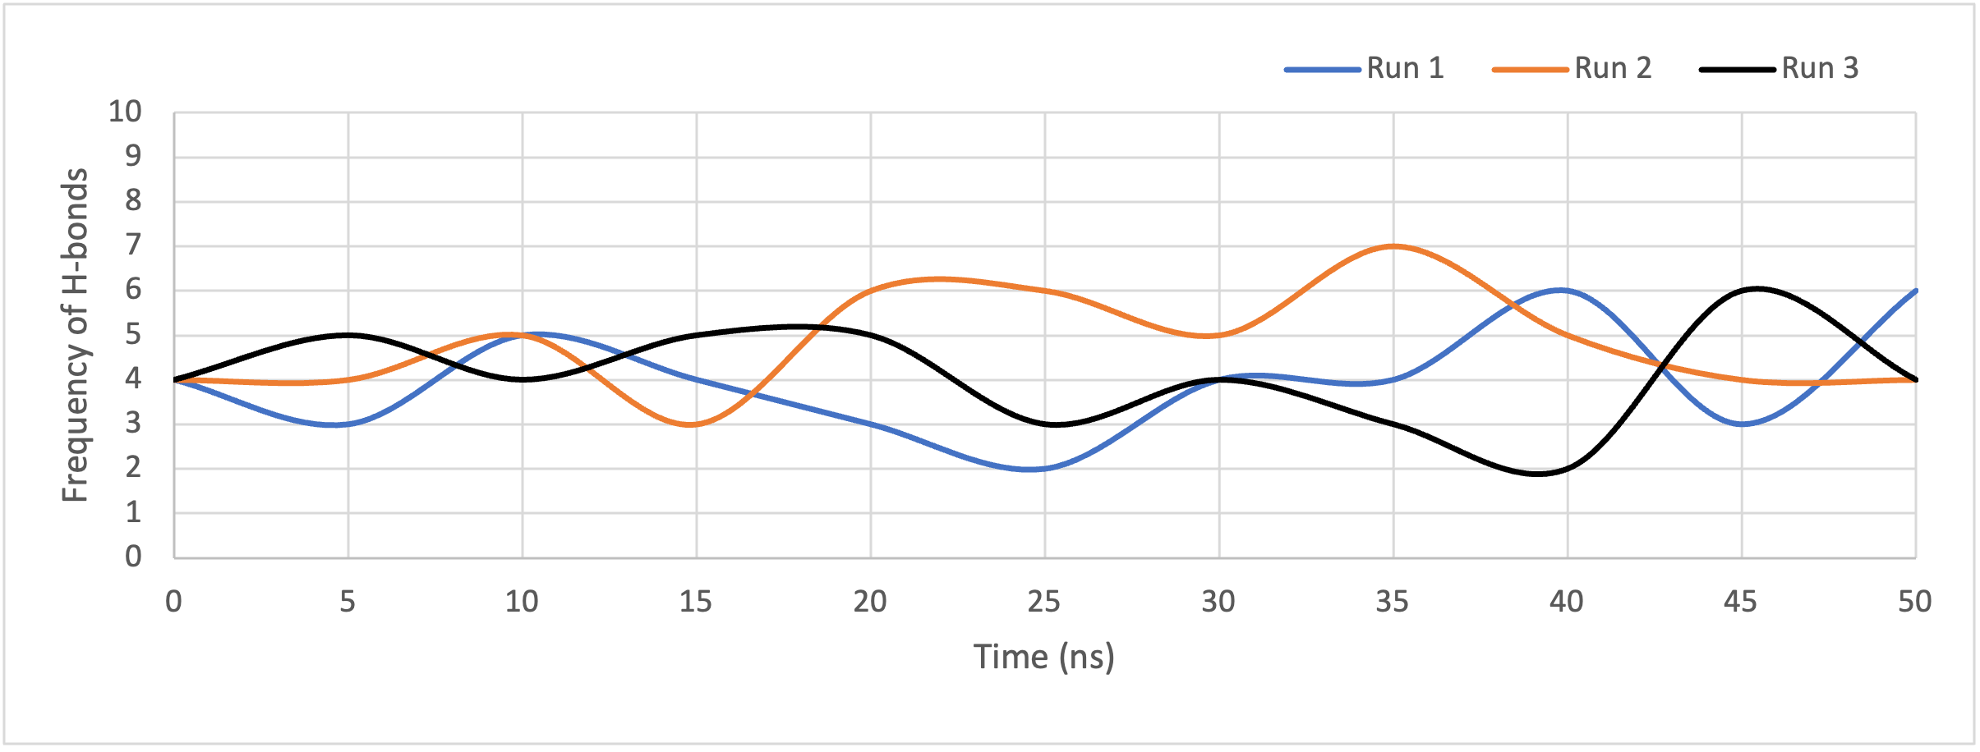

**Figure S1:** Number of H-bonds plotted against time for the (A) ACE-2 derived peptide and (B-G) the shorlisted peptide candidates in complex with the spike protein, over the course of 50 ns MD simulations.

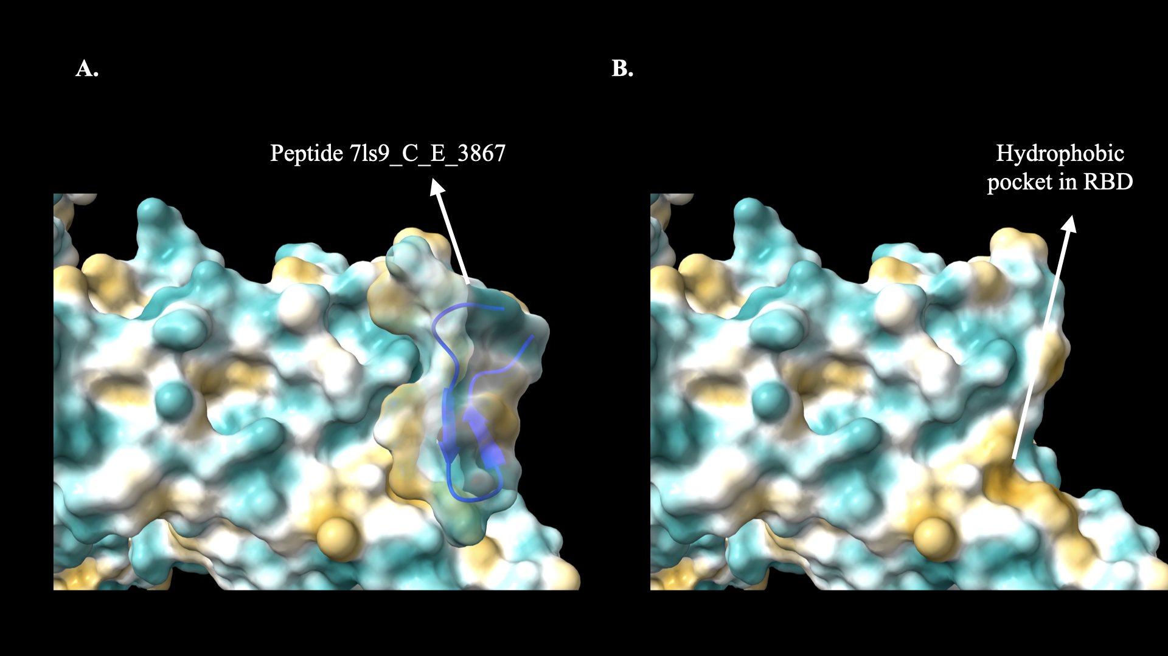

**Figure S2:** Structure of peptide 7ls9_C_E_3867 (shown in blue) bound within a hydrophobic pocket of the spike RBD. The hydrophobicity gradient is depicted using a color spectrum, ranging from golden (highly hydrophobic) to cyan (hydrophilic).

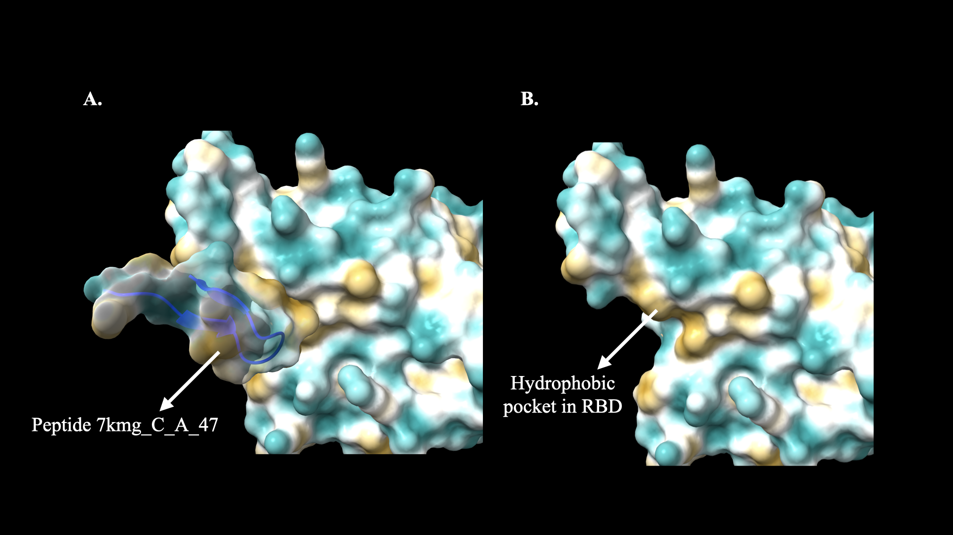

**Figure S3:**  Structure of peptide 7kmg_C_A_47 (shown in blue) bound within a hydrophobic pocket of the spike RBD. The hydrophobicity gradient is depicted using a color spectrum, ranging from golden (highly hydrophobic) to cyan (hydrophilic).

**A. ACE2-derived control peptide B. Peptide 7ls9_C_E_3867**

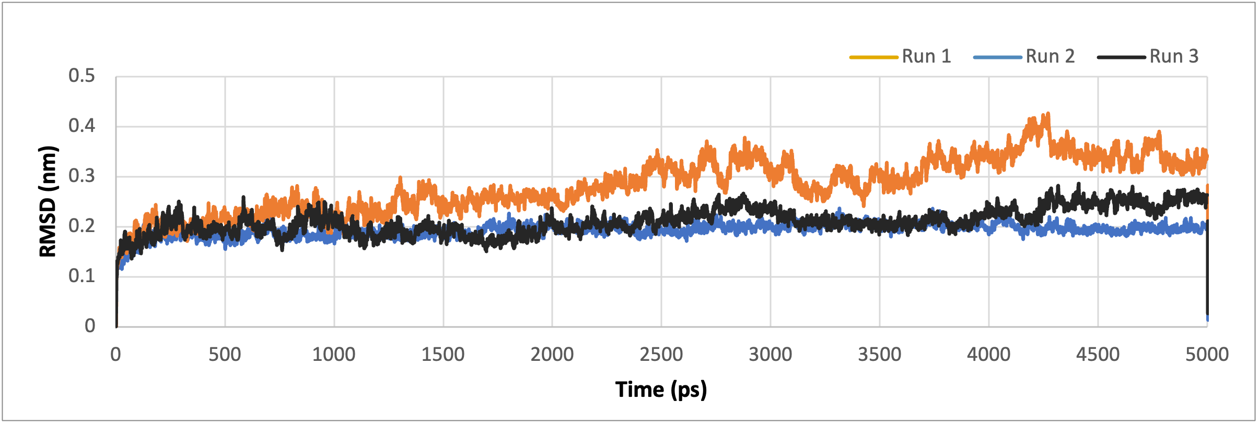 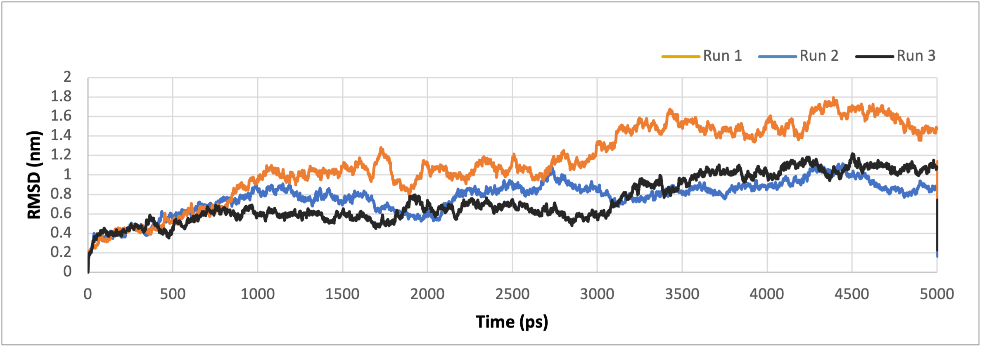

**C. Peptide 6xkp_B_M_919 D. Peptide 7kn5_B_D_619**

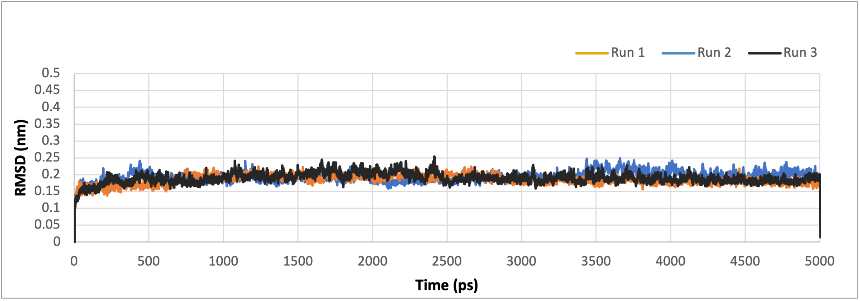 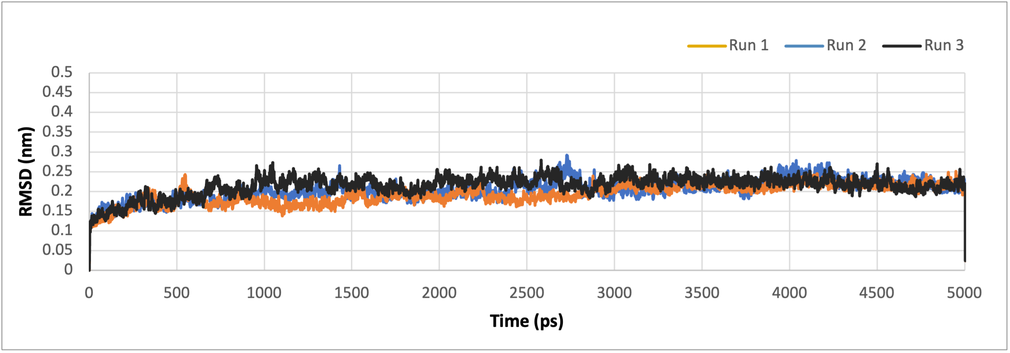

**E. Peptide 7m7w_S_C_752 F. Peptide 7kmg_C_A_47**

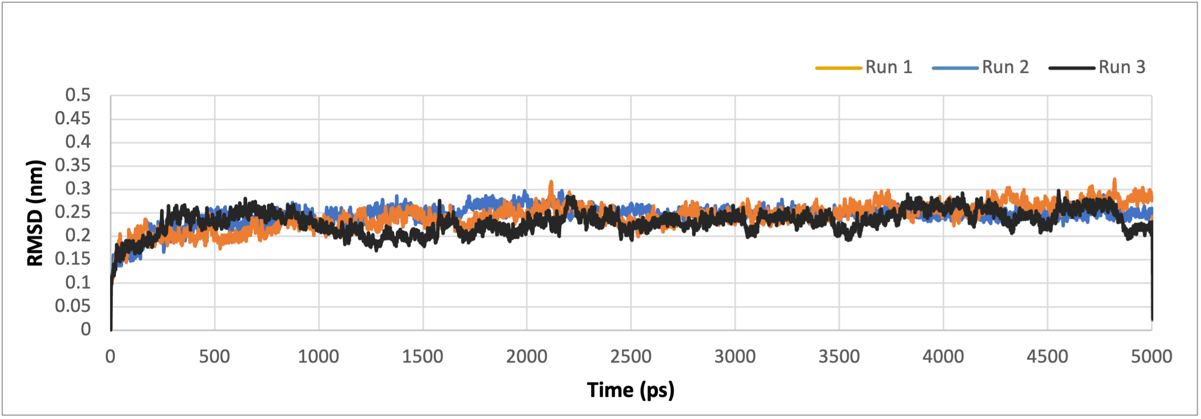 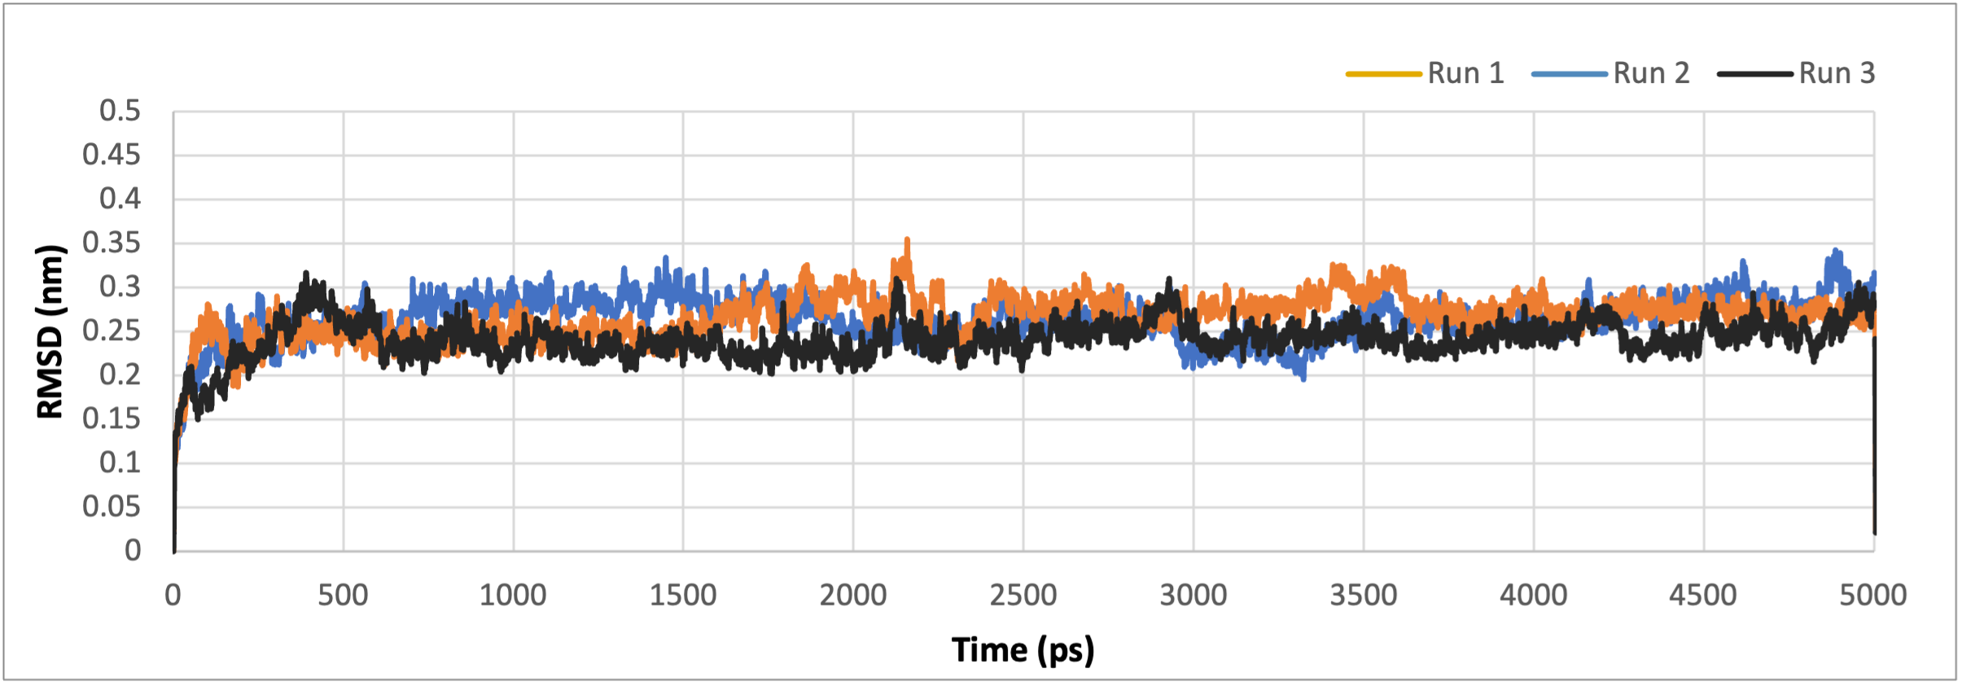

**G. Peptide 7l0n_R_A_312**

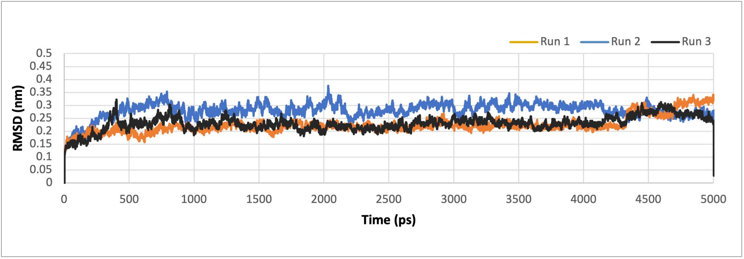

**Figure S4:** RMSD plots of the (A) ACE-2 derived peptide and (B-G) the shorlisted peptide candidates over 50 ns MD simulations.

**A. ACE2-derived control peptide B. Peptide 7ls9_C_E_3867**

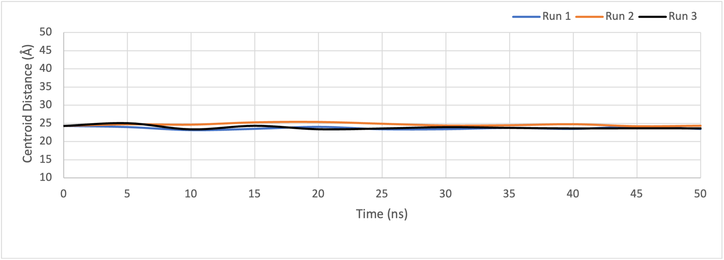 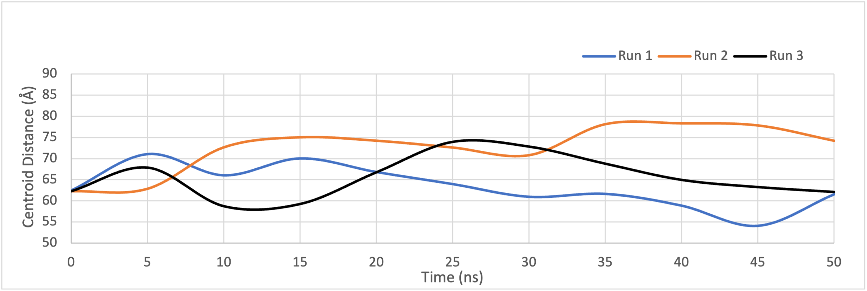

**C. Peptide 6xkp_B_M_919 D. Peptide 7kn5_B_D_619**

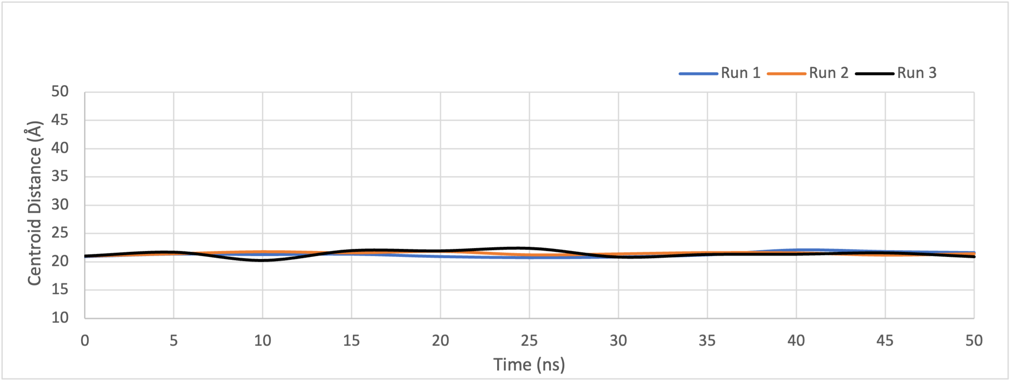 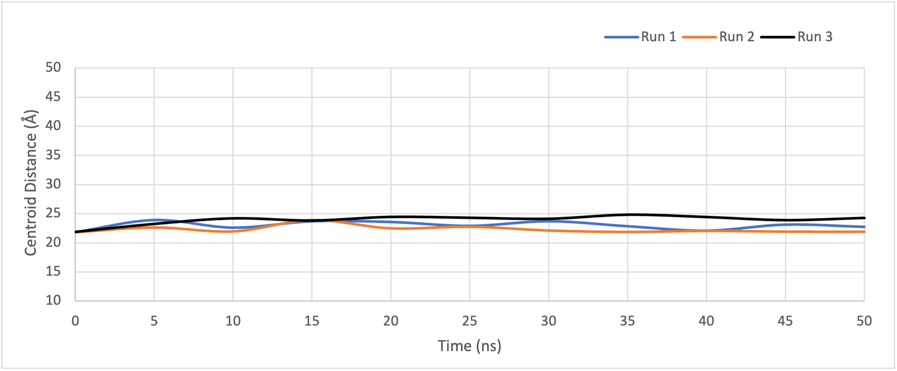

**E. Peptide 7m7w_S_C_752 F. Peptide 7kmg_C_A_47**

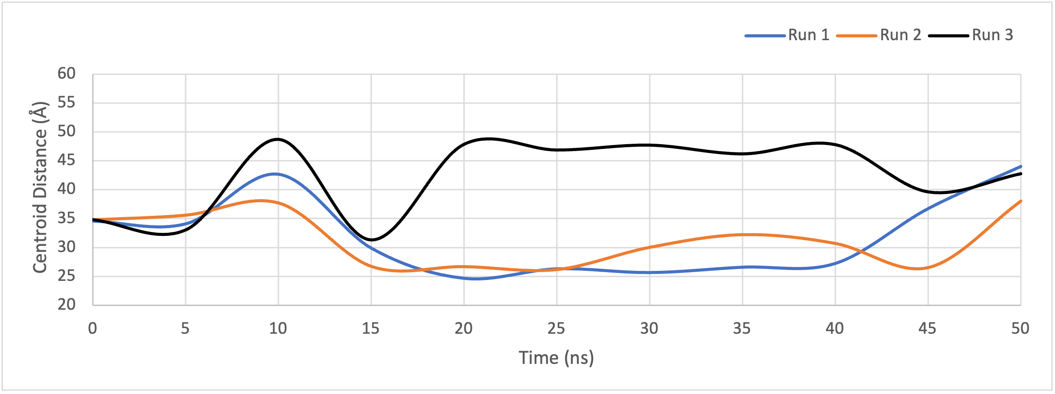 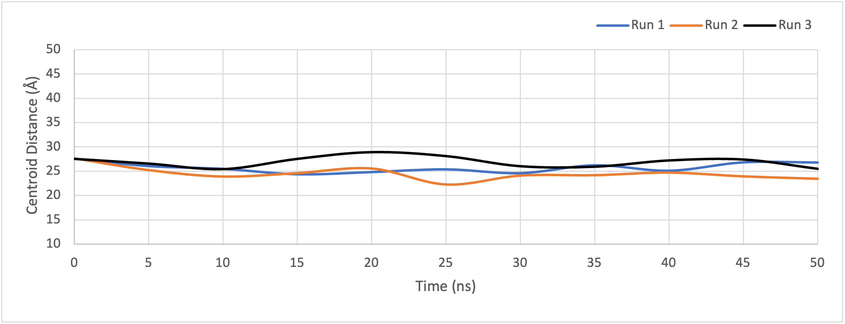

**G. Peptide 7l0n_R_A_312**

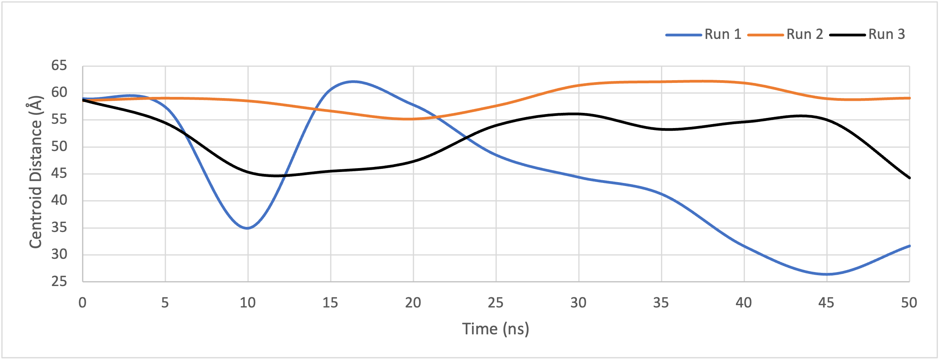

**Figure S5:** Distance between the centroids of peptide and the spike protein plotted against time for the (A) ACE-2 derived peptide and (B-G) the shorlisted peptide candidates in complex with the spike protein, over the course of 50 ns MD simulations.

**A. ACE2-derived control peptide B. Peptide 7ls9_C_E_3867**

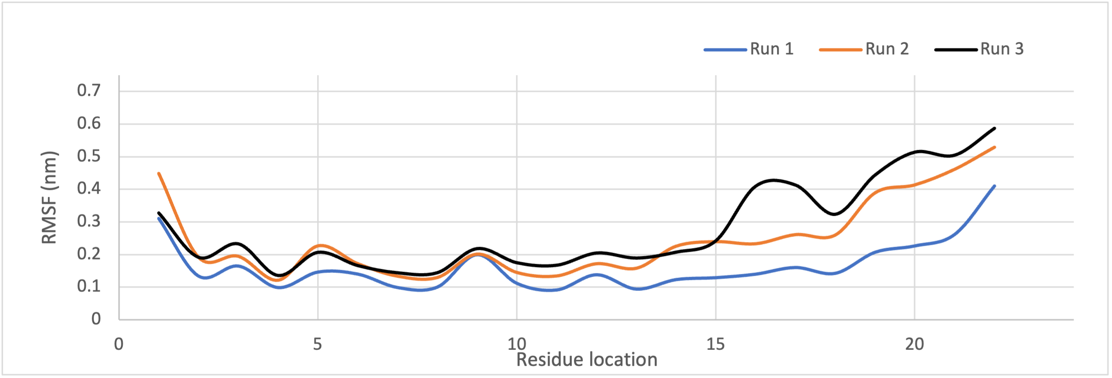 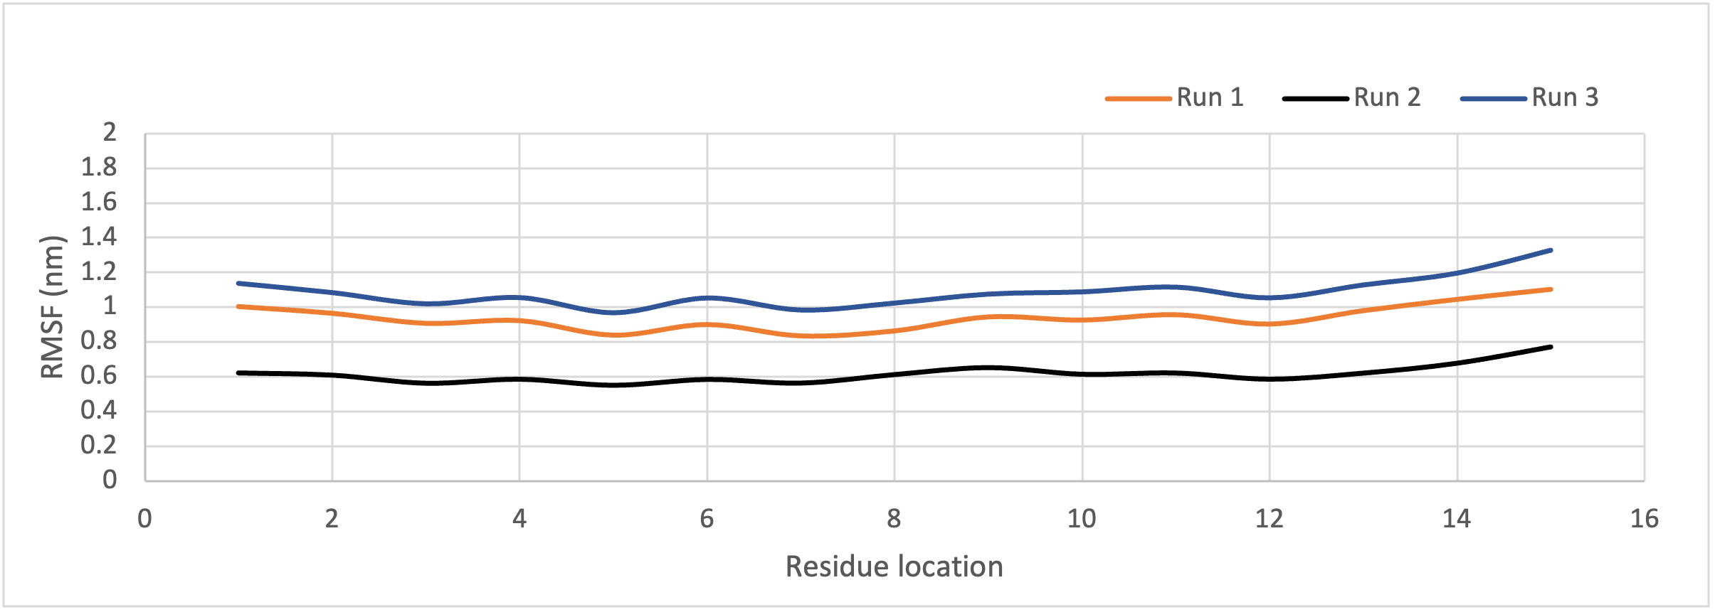

**C. Peptide 6xkp_B_M_919 D. Peptide 7kn5_B_D_619**

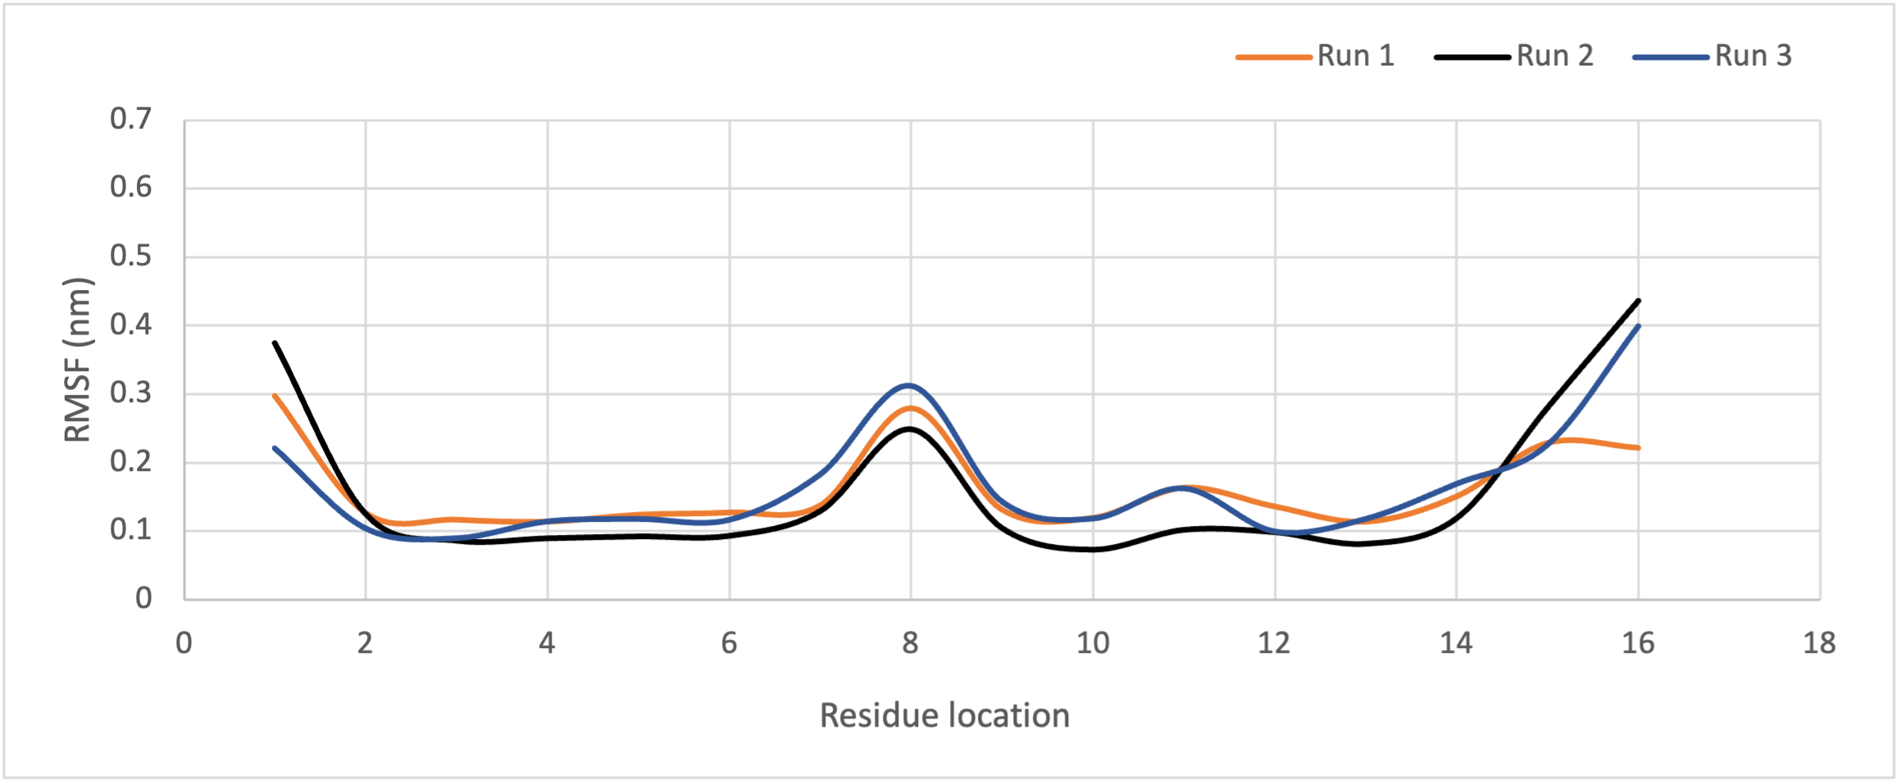 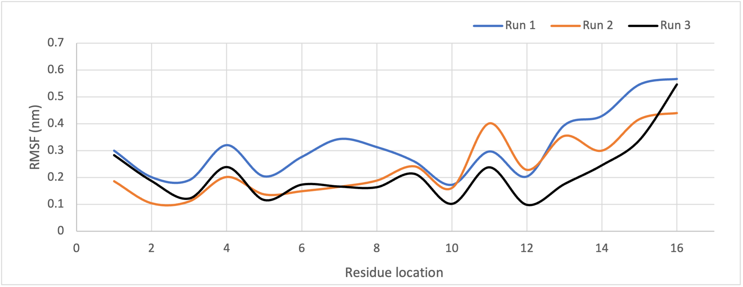

**E. Peptide 7m7w_S_C_752 F. Peptide 7kmg_C_A_47**

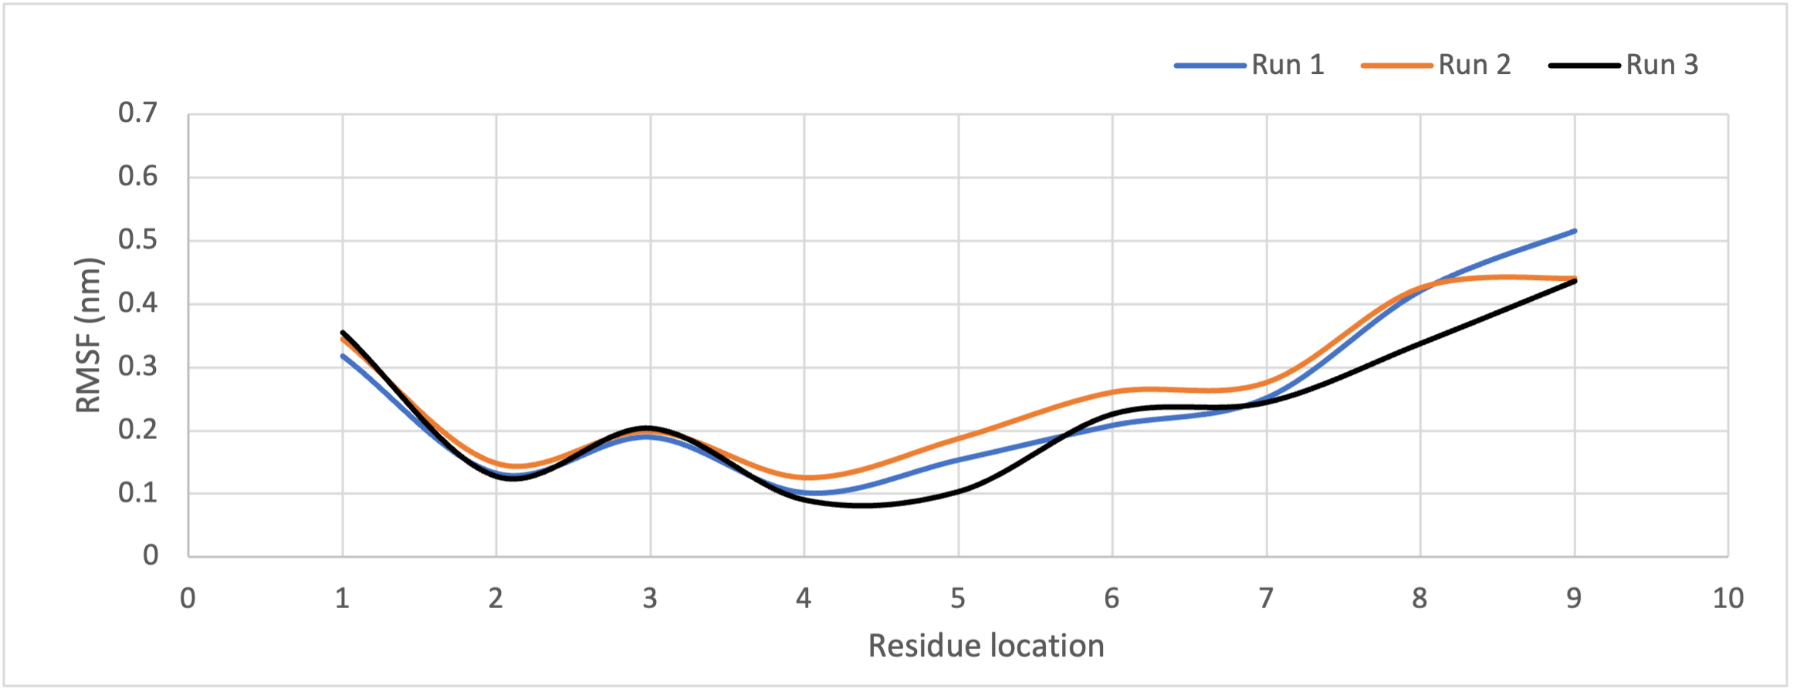 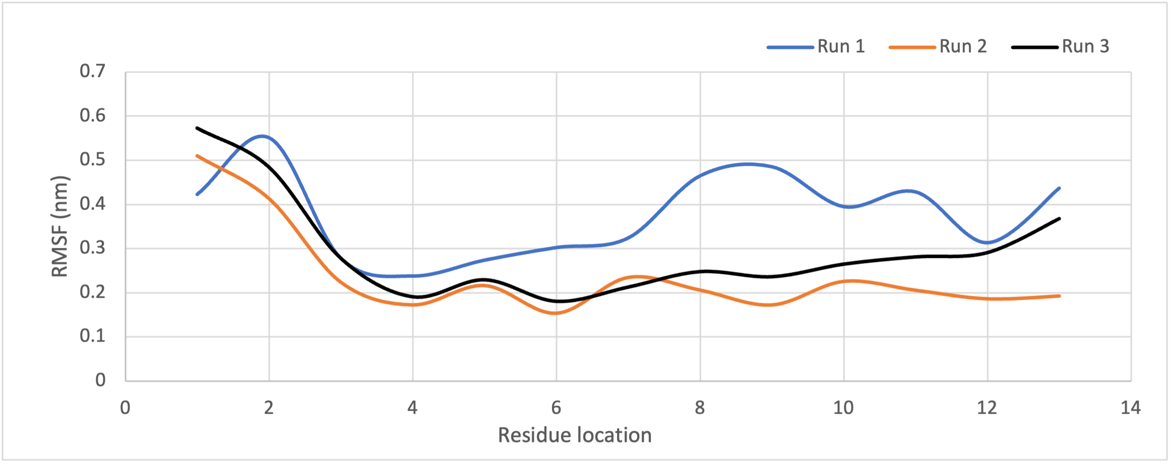

**G. Peptide 7l0n_R_A_312**

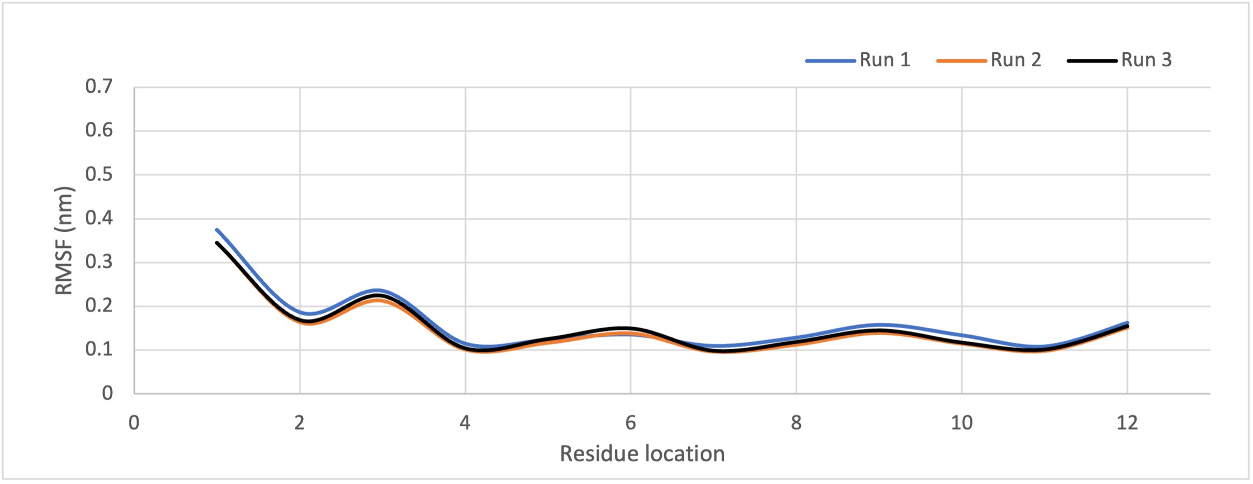

**Figure S6:** RMSF plot of the (A) ACE-2 derived peptide and (B-G) the shorlisted peptide candidates over 50 ns MD simulations.

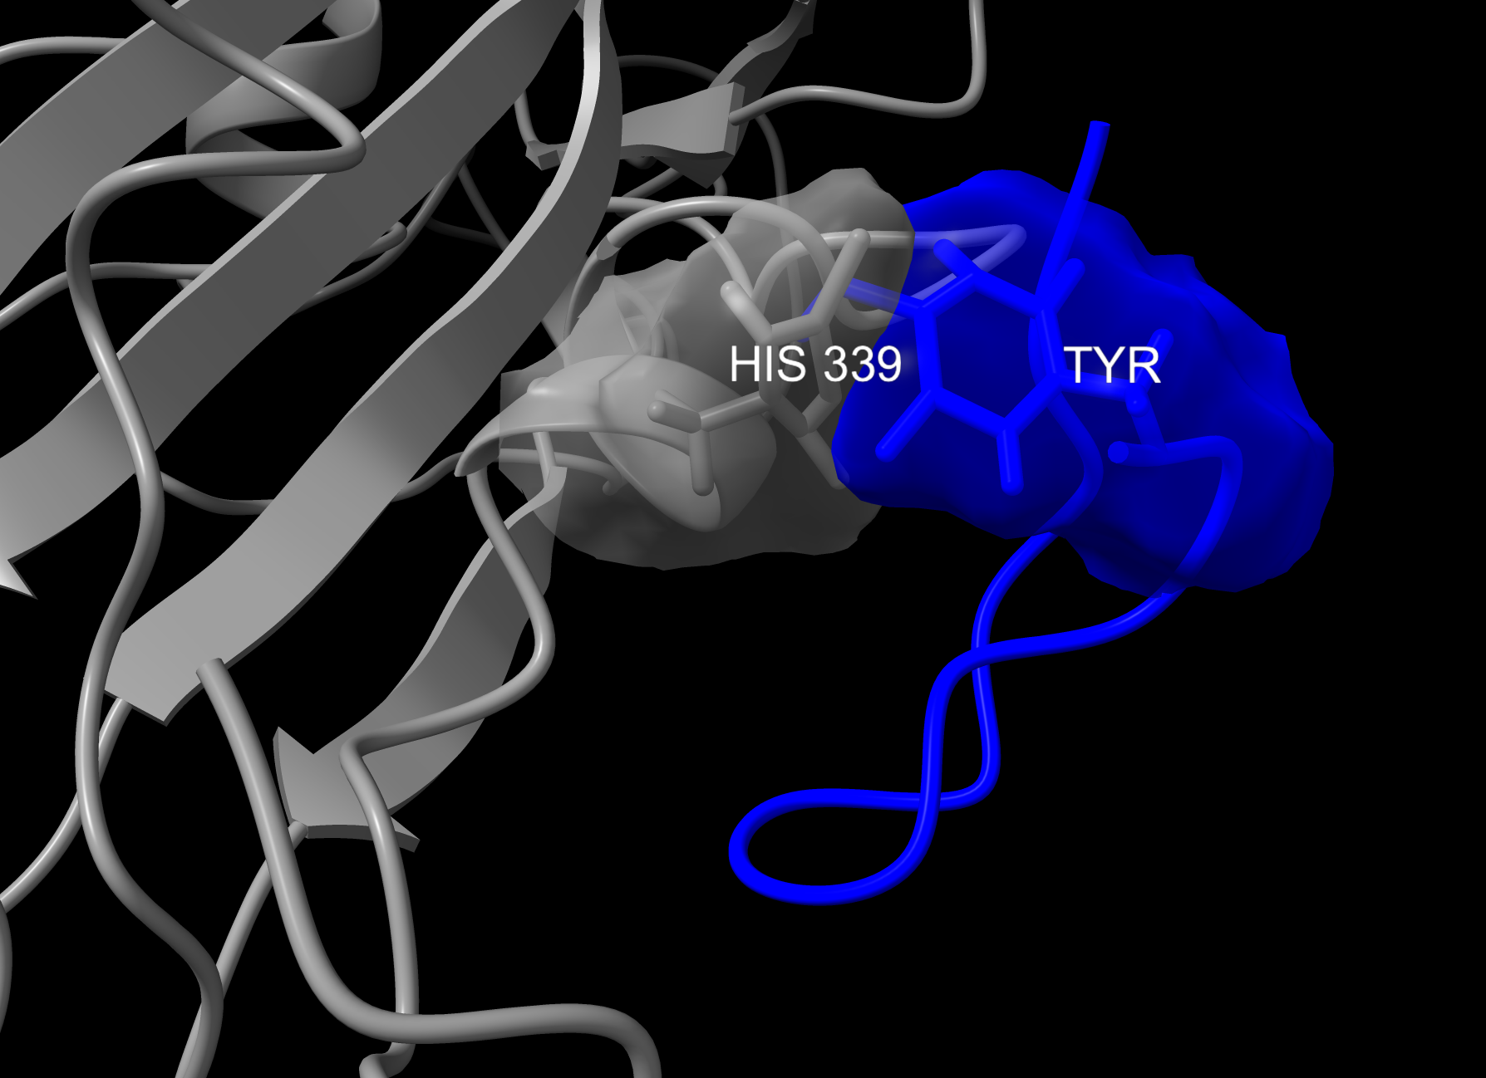**Figure S7:** The histidine residue at position 339 in the RBD (shown in grey) of Omicron variants XBB, BQ.1, and BA.2.75 disrupts local peptide packing by interfering with the arrangement of the terminal tyrosine on the peptide (shown in blue).

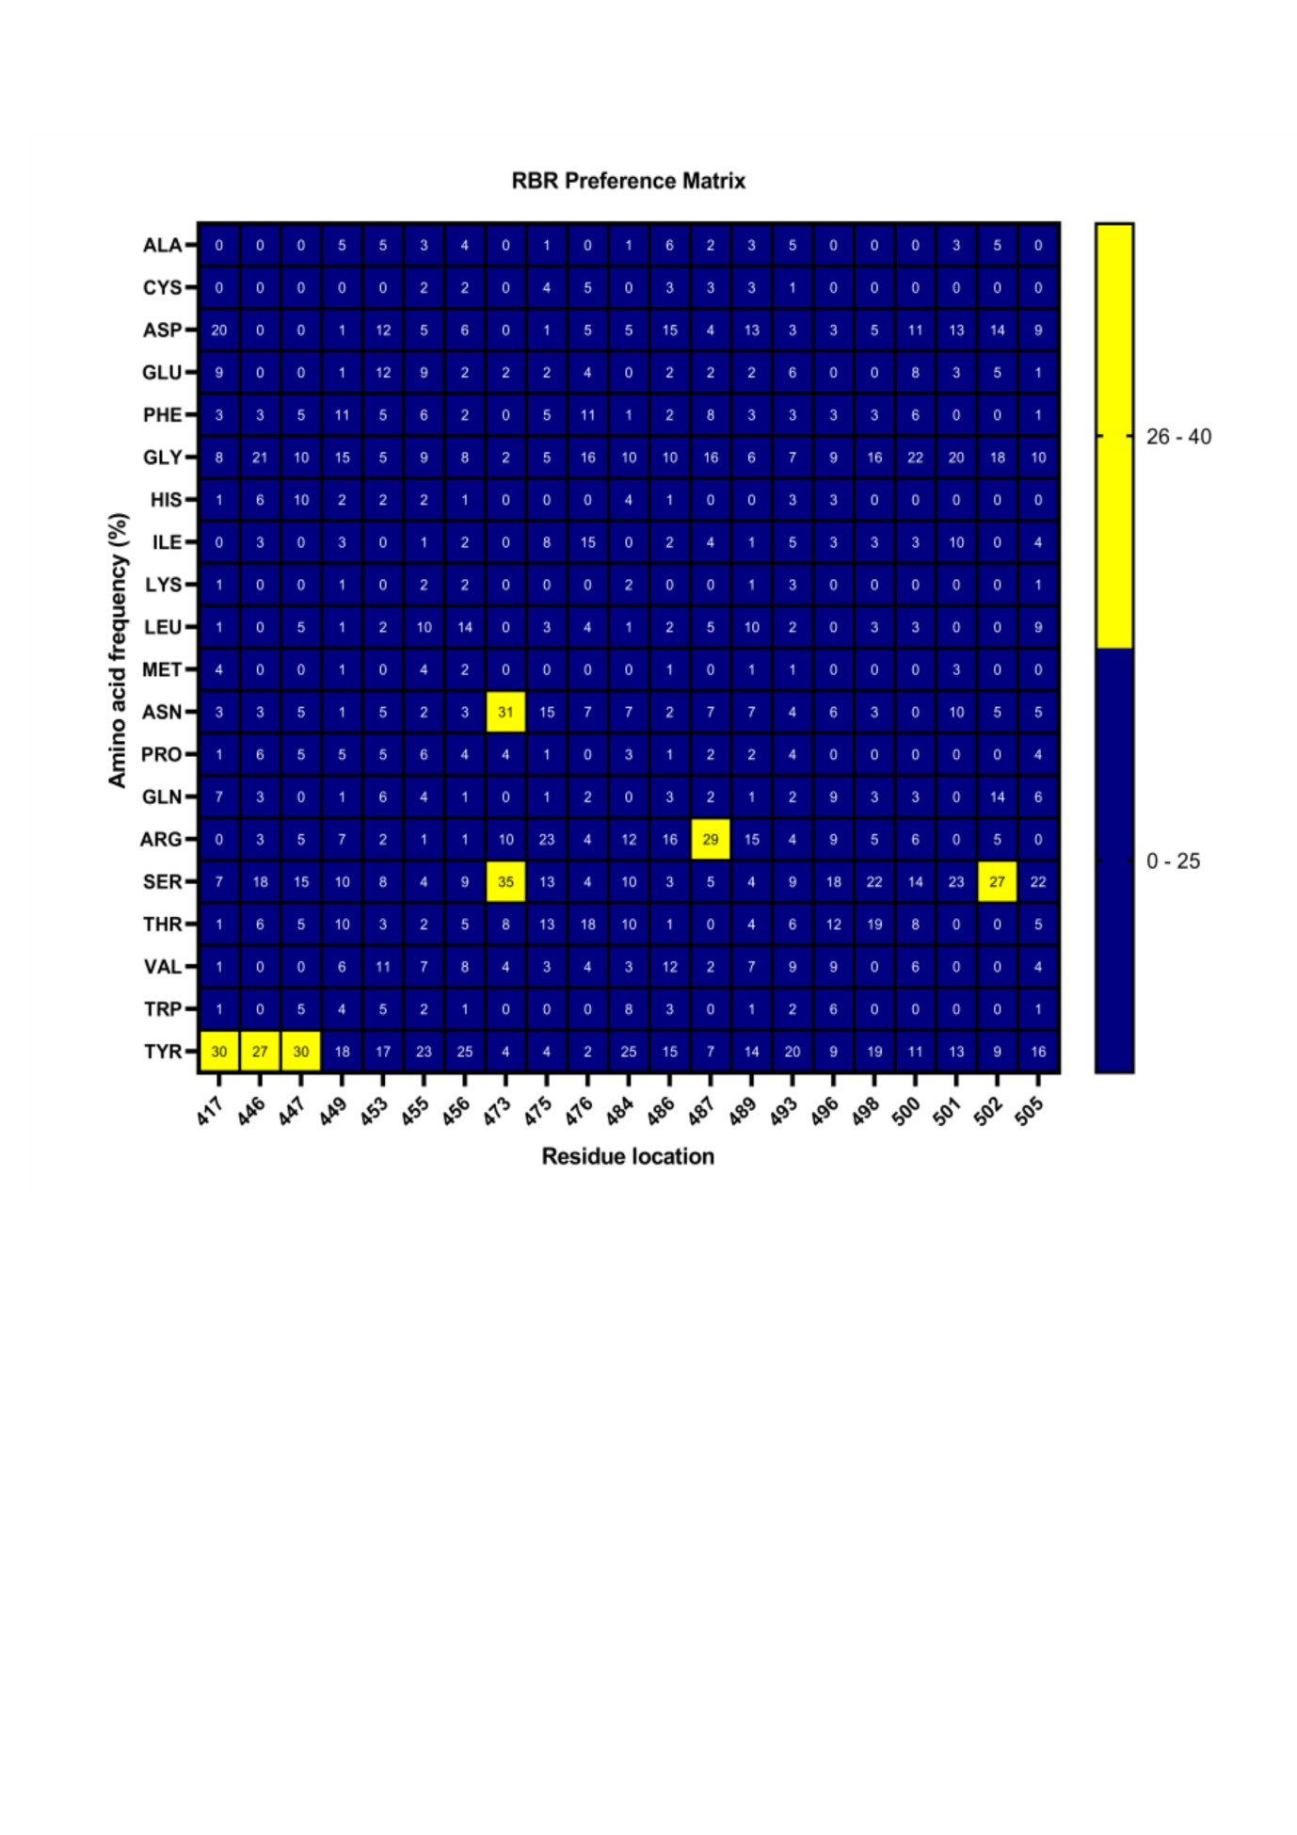

**Figure S8: RBS-amino acid preference matrix**. The figure shows the percentage frequency of occurrence of each amino acid as a binding partner in the 145 peptides from the library that interacted with at least one of the RBS. The data is presented for each of the 21 RBS positions. A threshold cutoff was applied to categorize the preference strength: amino acids with a frequency >40% were classified as strong preferences, those with a frequency between 25% and 40% were considered moderate preferences, and amino acids with a frequency <25% were categorized as having low or no preference.

**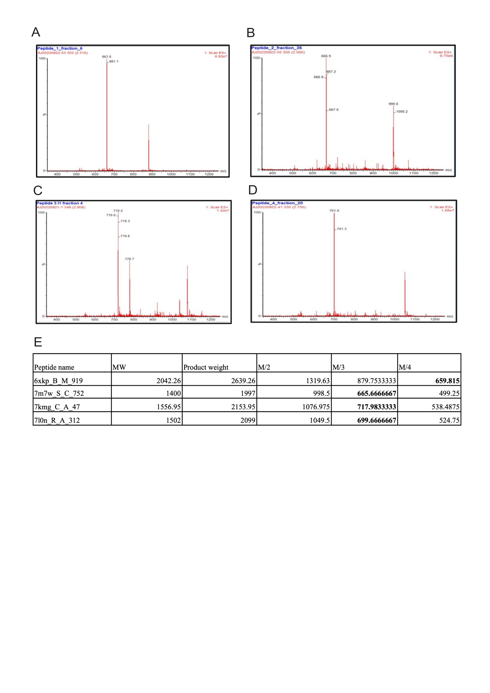  
Figure S9: LCMS validation of biotinylated peptide products.** The figure shows peaks corresponding to recorded fractions of molecular weights of the maleiamide reaction product (M) for (A) peptide 6xkp_B_M_919 (M/4), (B) peptide 7m7w_S_C_752 (M/3), (C) peptide 7kmg_C_A_47 (M/3), and (D) peptide 7l0n_R_A_312 (M/3). The theoretical molecular weights of the biotinylated products, along with their fractional weights, are listed in Table E for reference. The recorded fraction weights for the different peptide-biotin conjugation products are highlighted in bold.

**Table S1:** List of PDB IDs included in the dataset.

|  |
| --- |
|  |
| 6W41 | 7E23 | 7D0D | 7K8U | 7KXJ | 7NDC |
| 6XC2 | 7E5Y | 7CR5 | 7K8Z | 7KXK | 7NDD |
| 6XC4 | 7E7Y | 7D4G | 7K8X | 7KZB | 7NDA |
| 6XC3 | 7E88 | 7CWU | 7K8Y | 7LAB | 7NDB |
| 6XC7 | 7E7X | 7CWS | 7K90 | 7LAA | 7ND7 |
| 6XCN | 7E86 | 7CWT | 7K8M | 7LD1 | 7ND8 |
| 6XCM | 7DX4 | 7CWM | 7K8S | 7LCN | 7ND5 |
| 6XE1 | 7E8M | 7CWN | 7K9Z | 7LG0 | 7ND6 |
| 6XDG | 7DZX | 7CWL | 7KFX | 7LFZ | 7ND9 |
| 6XKQ | 7DZY | 7CWO | 7KFY | 7LG2 | 7ND3 |
| 6XKP | 7EAM | 7CYH | 7KFV | 7LG3 | 7ND4 |
| 7B3O | 7EJ4 | 7CYP | 7KFW | 7NX9 | 7NEH |
| 7BEL | 7EJ5 | 7CZX | 7KLH | 7NX7 | 7NEG |
| 7BEM | 7JMW | 7CZY | 7KLG | 7NX8 | 7LJR |
| 7BEJ | 7JMP | 7CZV | 7KN5 | 7LSS | 7LLF |
| 7BEK | 7JMO | 7CZW | 7KN6 | 7NX6 | 7LM8 |
| 7BEP | 7BYR | 7CZZ | 7KN7 | 7NXA | 7LOP |
| 7BEN | 7CAN | 7CZP | 7KMK | 7NXB | 7NTC |
| 7BEO | 7CAH | 7CZQ | 7KML | 7M71 | 7LQV |
| 7BEH | 7CAK | 7CZT | 7KMI | 7M6H | 7LQW |
| 7BEI | 7CAI | 7CZU | 7KMG | 7M6I | 7LS9 |
| 7C01 | 7CAC | 7CZR | 7KMH | 7M6F | 7M3I |
| 7C2L | 7CDJ | 7CZS | 7L06 | 7M6G |  |
| 7BWJ | 7CDI | 7A29 | 7L09 | 7M6D |  |
| 7C8V | 7CH4 | 7A5S | 7L02 | 7M6E |  |
| 7C8W | 7CH5 | 7A5R | 7L0N | 7M7W |  |
| 7DEO | 7CHO | 6ZDH | 7KQE | 7M7B |  |
| 7K43 | 7CHP | 6ZDG | 7L2E | 7M8J |  |
| 7K45 | 7CHF | 6ZER | 7L2F | 7LXY |  |
| 7K4N | 7CHE | 6ZFO | 7L2C | 7LXZ |  |
| 7JVA | 7CHH | 6ZH9 | 7L2D | 7LXW |  |
| 7JV6 | 7CHB | 6ZLR | 7KQB | 7LXX |  |
| 7JV4 | 7CHC | 6W7Y | 7KS9 | 7LY2 |  |
| 7JV2 | 7CJF | 7JW0 | 7L3N | 7LY3 |  |
| 7JWB | 7D0B | 7JVC | 7L58 | 7LY0 |  |
| 7DJZ | 7D03 | 7K8V | 7L56 | 7MF1 |  |
| 7DK0 | 7D00 | 7K8W | 7L57 | 7MKB |  |
| 7DPM | 7D0C | 7K8T | 7L5B | 7MMO |  |

**Table S2:** Characteristics of the peptide library comprising 273 distinct peptide sequences, including sequence length, interaction energy, PIZSA Z-score, and number of hydrogen bonds observed in the bound structure conformation.

|  |  |  |
| --- | --- | --- |
|  |  | |
| **Peptide** | **PIZSA Z-score** | **Association Type** | | **Interaction energy (kcal/mol)** | **Length** | **Total H-bonds** | **Sequence** |
| 7l2f_C_G_3598 | 2.988 | Stable association (BINDER) | | -15.66 | 17 | 5 | RDPRDYYDFWSGYDYYY |
| 7ls9_C_E_3867 | 3.153 | Stable association (BINDER) | | -12.93 | 15 | 1 | HRWAYCINGVCFGAY |
| 6xkp_B_M_919 | 3.279 | Stable association (BINDER) | | -12.13 | 16 | 8 | RGSSGWYRIGTRWGNW |
| 7m7w_S_C_752 | 2.884 | Stable association (BINDER) | | -11.17 | 9 | 3 | WSHYTYDYY |
| 7kn5_B_D_619 | 3.083 | Stable association (BINDER) | | -11.11 | 16 | 3 | VGTYYSGNYHYTCSDD |
| 7kmg_C_A_47 | 2.973 | Stable association (BINDER) | | -10.36 | 13 | 2 | WMGRIIPILGIAN |
| 7l0n_R_A_312 | 2.34 | Stable association (BINDER) | | -10.18 | 12 | 3 | YTRGAWFGESLI |
| 7kn5_A_E_744 | 3.075 | Stable association (BINDER) | | -9.45 | 16 | 9 | QSGSYYWCGSDWHEYE |
| 7m7w_S_A_318 | 3.014 | Stable association (BINDER) | | -8.71 | 8 | 5 | NYYGWGDD |
| 7mkb_C_A_59 | 3.338 | Stable association (BINDER) | | -8.53 | 26 | 4 | YWDGETRKVKAHSQTHRVDLGTLRGY |
| 7djz_C_A_47 | 3.533 | Stable association (BINDER) | | -8.46 | 19 | 1 | WMGRIIPVLGIANYAQEVQ |
| 7m6d_C_H_736 | 2.651 | Stable association (BINDER) | | -8.28 | 11 | 1 | RDLEVVGAMDV |
| 7ly3_B_F_1258 | 2.651 | Stable association (BINDER) | | -8.25 | 10 | 4 | VIWYDGSNRY |
| 7l2c_A_H_585 | 2.467 | Stable association (BINDER) | | -8.24 | 9 | 6 | GYTLIELSM |
| 7e7x_B_M_877 | 2.852 | Stable association (BINDER) | | -8.22 | 9 | 4 | GYTLIEISI |
| 7bel_R_A_292 | 2.692 | Stable association (BINDER) | | -8.13 | 12 | 4 | KGGSYAYYYYMD |
| 7jmo_A_H_290 | 3.3 | Stable association (BINDER) | | -8.13 | 11 | 3 | RDLERAGGMDV |
| 7cjf_C_A_97 | 3.263 | Stable association (BINDER) | | -8.01 | 11 | 5 | RDLQELGSLDY |
| 7eam_B_C_935 | 3.383 | Stable association (BINDER) | | -7.96 | 8 | 2 | RFYDYVNY |
| 7e88_F_B_363 | 3.18 | Stable association (BINDER) | | -7.89 | 9 | 5 | VDNALQSGN |
| 7lm8_A_H_294 | 3.586 | Stable association (BINDER) | | -7.85 | 11 | 6 | RPPRNYYDRSG |
| 7cdi_E_H_287 | 2.495 | Stable association (BINDER) | | -7.55 | 10 | 3 | RDLVVYGMDV |
| 7e7x_B_M_949 | 3.523 | Stable association (BINDER) | | -7.52 | 8 | 0 | TGPAIAAAETNWFD |
| 7ld1_C_M_2997 | 2.518 | Stable association (BINDER) | | -7.52 | 12 | 6 | VDDSWSGYDLLS |
| 7m3i_C_A_99 | 2.8 | Stable association (BINDER) | | -7.44 | 6 | 4 | RPDGNL |
| 7dpm_I_G_1378 | 2.152 | Stable association (BINDER) | | -7.42 | 11 | 5 | YYDSSGYYFRE |
| 7e5y_R_H_494 | 2.176 | Stable association (BINDER) | | -7.35 | 7 | 0 | RDLMEVGGMDV |
| 6xc2_A_H_505 | 2.17 | Stable association (BINDER) | | -7.21 | 10 | 3 | RDLDVYGLDV |
| 7dpm_F_H_1650 | 3.622 | Stable association (BINDER) | | -7.18 | 14 | 7 | KVQWKVDNALQSGN |
| 7kn6_A_C_281 | 2.961 | Stable association (BINDER) | | -7.08 | 18 | 11 | YCATEGSLGGWGRDFGSW |
| 7bel_X_F_1451 | 2.967 | Stable association (BINDER) | | -7.07 | 7 | 3 | IYYDDLL |
| 7chp_E_H_283 | 3.411 | Stable association (BINDER) | | -7.05 | 10 | 4 | RDLQEHGMDV |
| 7c01_B_C_920 | 2.119 | Stable association (BINDER) | | -6.99 | 12 | 3 | RVLPMYGDYLDY |
| 7c2l_B_I_3683 | 2.72 | Stable association (BINDER) | | -6.93 | 17 | 1 | TAVAGTPDLFDYYYGMD |
| 7deo_D_C_497 | 2.545 | Stable association (BINDER) | | -6.9 | 8 | 3 | WYDGSNRF |
| 7k9z_E_H_52 | 3.243 | Stable association (BINDER) | | -6.87 | 8 | 0 | IPMFGTTN |
| 7nd5_B_H_3072 | 3.356 | Stable association (BINDER) | | -6.77 | 10 | 4 | RDLMVYGIDV |
| 6xe1_E_H_96 | 2.448 | Stable association (BINDER) | | -6.7 | 11 | 4 | RDLDVSGGMDV |
| 7jwb_A_D_47 | 2.244 | Stable association (BINDER) | | -6.63 | 15 | 5 | EELVARIYPSSGYTY |
| 7mkb_C_A_152 | 2.885 | Stable association (BINDER) | | -6.62 | 16 | 1 | VAEQLRAYLEGTCVEW |
| 7e86_C_A_284 | 2.712 | Stable association (BINDER) | | -6.61 | 10 | 5 | RDAQNYGMDV |
| 7chf_R_H_97 | 3.642 | Stable association (BINDER) | | -6.45 | 10 | 3 | RDLGPYGMDV |
| 7kfw_B_C_487 | 2.985 | Stable association (BINDER) | | -6.39 | 13 | 7 | RGDVSGYRYGLDY |
| 7eam_B_C_863 | 2.75 | Stable association (BINDER) | | -6.32 | 7 | 4 | GFNIKDT |
| 7kqb_A_H_3333 | 3.167 | Stable association (BINDER) | | -6.32 | 9 | 2 | RLITMVRGE |
| 7eam_A_H_230 | 2.785 | Stable association (BINDER) | | -6.29 | 8 | 4 | GFNIKDTY |
| 7bem_E_H_26 | 2.78 | Stable association (BINDER) | | -6.26 | 8 | 5 | GLTVNRNY |
| 7chb_R_H_97 | 2.079 | Stable association (BINDER) | | -6.16 | 11 | 2 | RDLGEAGGMDV |
| 7deo_D_C_545 | 2.178 | Stable association (BINDER) | | -6.15 | 19 | 0 | PPGLRFRFDY |
| 7neh_E_H_97 | 2.074 | Stable association (BINDER) | | -6.14 | 10 | 5 | RDFYEGSFDI |
| 7czx_B_I_3570 | 2.92 | Stable association (BINDER) | | -6.14 | 12 | 1 | YDILTGQPPDYW |
| 7lop_A_H_1613 | 3.497 | Stable association (BINDER) | | -6.13 | 8 | 1 | VRGALPPY |
| 6xkq_A_H_248 | 2.194 | Stable association (BINDER) | | -6.1 | 12 | 7 | SDNYGFPYNGMD |
| 7e8m_E_H_217 | 2.188 | Stable association (BINDER) | | -6.04 | 8 | 4 | GITVSSNY |
| 7kfv_B_C_416 | 3.706 | Stable association (BINDER) | | -5.9 | 8 | 5 | GFTVSSNY |
| 7kn7_A_B_287 | 3.413 | Stable association (BINDER) | | -5.81 | 16 | 8 | QSGSYYWCGSDWHEYD |
| 7mf1_A_H_295 | 2.938 | Stable association (BINDER) | | -5.75 | 8 | 6 | RRYGSGWY |
| 7m6i_A_M_3277 | 3.784 | Stable association (BINDER) | | -5.68 | 12 | 0 | RIISMFGIAN |
| 6xc2_A_L_220 | 1.968 | Stable association (BINDER) | | -5.66 | 6 | 4 | QGISSY |
| 7l0n_S_N_1389 | 2.996 | Stable association (BINDER) | | -5.61 | 6 | 5 | YVSPTY |
| 7lcn_K_M_3959 | 2.717 | Stable association (BINDER) | | -5.53 | 7 | 1 | FGVVTDW |
| 7e88_I_G_1249 | 2.223 | Stable association (BINDER) | | -5.52 | 8 | 5 | EFIVSRNY |
| 7ben_E_H_276 | 2.008 | Stable association (BINDER) | | -5.43 | 12 | 5 | PHCNSTSCYDAF |
| 7m6e_A_H_3448 | 2.146 | Stable association (BINDER) | | -5.43 | 9 | 1 | WGYNYGSHF |
| 7nxa_E_B_863 | 3.544 | Stable association (BINDER) | | -5.34 | 7 | 2 | QSVPSSY |
| 7nxa_E_H_99 | 3.491 | Stable association (BINDER) | | -5.28 | 8 | 3 | DGGKLWVY |
| 7nx7_E_A_647 | 2.17 | Stable association (BINDER) | | -5.26 | 8 | 5 | GLTVSSNY |
| 7c8w_B_A_26 | 3.057 | Stable association (BINDER) | | -5.22 | 12 | 3 | GFPVEVWRMEWY |
| 7cdj_E_H_294 | 2.76 | Stable association (BINDER) | | -5.2 | 8 | 0 | FSHQQL |
| 7ljr_A_S_3046 | 2.379 | Stable association (BINDER) | | -5.07 | 9 | 3 | DYYYDSSGY |
| 7e88_C_A_24 | 2.244 | Stable association (BINDER) | | -5.04 | 9 | 5 | SEFIVSRNY |
| 7l2e_C_I_3869 | 3.269 | Stable association (BINDER) | | -5 | 10 | 4 | VISYDGSNKH |
| 7chc_R_H_97 | 2.341 | Stable association (BINDER) | | -4.95 | 10 | 3 | RDYGDYYFDY |
| 7e23_A_B_276 | 2.556 | Stable association (BINDER) | | -4.93 | 19 | 5 | CARGNTMVRGVIIPFEYWD |
| 7cho_A_B_913 | 2.814 | Stable association (BINDER) | | -4.91 | 14 | 3 | RALQVGATSDYFDY |
| 7can_B_A_47 | 1.968 | Stable association (BINDER) | | -4.85 | 15 | 1 | GVAAIESYGHGTRYA |
| 7kxj_B_M_3564 | 2.11 | Stable association (BINDER) | | -4.77 | 8 | 2 | YSASDLYS |
| 7lqv_B_W_3621 | 1.762 | Stable association (BINDER) | | -4.73 | 14 | 6 | QTVDTAIEKYYGMD |
| 7bwj_E_H_509 | 3.263 | Stable association (BINDER) | | -4.69 | 8 | 0 | GIVVVP |
| 7c8w_B_A_47 | 1.789 | Stable association (BINDER) | | -4.69 | 19 | 5 | GVAAIESYGHGTRYADSVK |
| 7e5y_A_C_1102 | 3.771 | Stable association (BINDER) | | -4.67 | 9 | 2 | RDLMEVGGM |
| 7e23_A_B_207 | 3.104 | Stable association (BINDER) | | -4.57 | 11 | 1 | CAVYGGSFSGY |
| 7jv4_B_E_3510 | 1.827 | Stable association (BINDER) | | -4.57 | 12 | 1 | DTSNKHSWTPAR |
| 7k8v_C_M_3262 | 1.791 | Stable association (BINDER) | | -4.53 | 10 | 0 | DPRIAVAGP |
| 7nd4_B_F_3589 | 2.21 | Stable association (BINDER) | | -4.35 | 12 | 2 | CSGGTCYPKYYY |
| 7kmg_C_A_100 | 3.348 | Stable association (BINDER) | | -4.32 | 6 | 3 | YYEARH |
| 7chc_R_A_632 | 3.265 | Stable association (BINDER) | | -4.22 | 7 | 0 | SGFAFTTY |
| 7ly3_A_C_876 | 3.109 | Stable association (BINDER) | | -4.22 | 8 | 2 | ADSIGSSW |
| 7cwl_B_G_3314 | 3.543 | Stable association (BINDER) | | -4.18 | 7 | 1 | RHATLMN |
| 7bek_E_H_26 | 2.137 | Stable association (BINDER) | | -4.15 | 8 | 4 | GVTVSSNY |
| 7l2e_A_H_3456 | 2.737 | Stable association (BINDER) | | -4.08 | 9 | 5 | DSGYNYGYS |
| 6xc3_C_A_533 | 2.386 | Stable association (BINDER) | | -4.05 | 6 | 3 | QLNSYP |
| 7beo_X_E_1770 | 3.028 | Stable association (BINDER) | | -4.03 | 11 | 5 | VVVAARNHYYN |
| 7jv2_A_L_170 | 2.421 | Stable association (BINDER) | | -4.01 | 13 | 2 | YDTSNKHSWTPAR |
| 7nx9_E_B_864 | 3.767 | Stable association (BINDER) | | -4 | 9 | 0 | SVPSSY |
| 7k90_C_H_3104 | 2.163 | Stable association (BINDER) | | -3.98 | 9 | 0 | NDFWSGY |
| 7k9z_E_B_690 | 3.76 | Stable association (BINDER) | | -3.97 | 8 | 0 | WMGWISPNSGGTD |
| 7kfx_A_H_221 | 2.649 | Stable association (BINDER) | | -3.96 | 8 | 7 | GFTVSNNY |
| 7lcn_A_B_2525 | 2.508 | Stable association (BINDER) | | -3.96 | 7 | 0 | SPFGVVT |
| 7l2c_B_C_1093 | 3.414 | Stable association (BINDER) | | -3.94 | 11 | 2 | WAYKSTWYFGY |
| 7jwb_A_D_30 | 2.311 | Stable association (BINDER) | | -3.81 | 10 | 3 | YSYYSYIGWV |
| 7ljr_A_S_2993 | 3.007 | Stable association (BINDER) | | -3.76 | 11 | 2 | WMGRIIPIFGI |
| 7l5b_A_H_219 | 3.493 | Stable association (BINDER) | | -3.7 | 10 | 1 | WINPISDGTN |
| 7lxz_A_E_1213 | 2.887 | Stable association (BINDER) | | -3.67 | 9 | 2 | WINPISSGT |
| 7lm8_A_M_735 | 3.75 | Stable association (BINDER) | | -3.57 | 8 | 2 | RGVYSSGW |
| 7m7w_R_H_1133 | 3.763 | Stable association (BINDER) | | -3.52 | 8 | 0 | RIILMSGM |
| 7e8m_E_H_243 | 2.204 | Stable association (BINDER) | | -3.47 | 7 | 4 | YSGGSTY |
| 7ej5_B_I_3313 | 2.173 | Stable association (BINDER) | | -3.43 | 10 | 0 | GNNPNNDDTT |
| 7kn7_A_H_411 | 2.725 | Stable association (BINDER) | | -3.37 | 10 | 3 | RDFGDFYFDY |
| 7m6d_C_H_665 | 3.197 | Stable association (BINDER) | | -3.3 | 8 | 4 | GITVVRNY |
| 7l0n_R_H_1134 | 3.368 | Stable association (BINDER) | | -3.15 | 15 | 2 | TIGTAGDTYYPDSVK |
| 7c01_B_L_420 | 2.609 | Stable association (BINDER) | | -3.13 | 16 | 4 | SPSSLSASVGDRVTIT |
| 7e5y_R_H_423 | 1.96 | Stable association (BINDER) | | -3.12 | 8 | 3 | EITVSSNY |
| 7bek_E_H_52 | 2.894 | Stable association (BINDER) | | -3.02 | 7 | 1 | YPGGSTF |
| 7e8m_E_L_430 | 3.283 | Stable association (BINDER) | | -3 | 6 | 3 | SVSSSY |
| 7jwb_C_D_298 | 1.877 | Stable association (BINDER) | | -2.98 | 8 | 3 | YPSSGYTY |
| 7ly0_A_L_157 | 1.791 | Stable association (BINDER) | | -2.95 | 6 | 5 | LAKHYA |
| 7c2l_A_H_3161 | 2.897 | Stable association (BINDER) | | -2.94 | 8 | 4 | GYTLTELS |
| 7lop_A_B_462 | 3.76 | Stable association (BINDER) | | -2.93 | 6 | 0 | YGFITYW |
| 7cho_E_H_291 | 1.753 | Stable association (BINDER) | | -2.91 | 13 | 6 | RALQVGATSDYFD |
| 7beh_E_H_245 | 2.122 | Stable association (BINDER) | | -2.83 | 10 | 2 | WINPNSGGTN |
| 7l57_B_H_3007 | 2.49 | Stable association (BINDER) | | -2.82 | 10 | 0 | NPISDGTN |
| 7dk0_C_A_50 | 1.748 | Stable association (BINDER) | | -2.79 | 11 | 1 | RIIPIFGSSNY |
| 7k4n_A_H_1101 | 2.231 | Stable association (BINDER) | | -2.79 | 6 | 1 | GSCSDG |
| 7lxy_J_M_4129 | 3.433 | Stable association (BINDER) | | -2.71 | 7 | 2 | YTFTGYY |
| 7bel_X_D_1564 | 2.368 | Stable association (BINDER) | | -2.53 | 8 | 2 | YDASNLET |
| 7c8w_B_A_99 | 2.559 | Stable association (BINDER) | | -2.5 | 6 | 1 | KDDGQL |
| 7m6h_B_D_3053 | 1.921 | Stable association (BINDER) | | -2.49 | 9 | 0 | WMGWMNPISGNTG |
| 7lab_C_H_3818 | 2.022 | Stable association (BINDER) | | -2.44 | 10 | 3 | LVDPEDGETI |
| 6xcm_B_N_3148 | 3.644 | Stable association (BINDER) | | -2.42 | 8 | 0 | RGEGWELPYDY |
| 7e5y_R_L_214 | 3.252 | Stable association (BINDER) | | -2.38 | 7 | 1 | SSNVEND |
| 7l0n_S_M_1608 | 3.771 | Stable association (BINDER) | | -2.34 | 6 | 0 | GDSSGYYY |
| 7k8s_B_O_3501 | 3.791 | Stable association (BINDER) | | -2.27 | 11 | 0 | GFTFSIYGMH |
| 7l0n_S_C_672 | 3.211 | Stable association (BINDER) | | -2.24 | 8 | 2 | ASGYPFTS |
| 7l58_B_H_3257 | 2.472 | Stable association (BINDER) | | -2.18 | 10 | 4 | RINPNSGGTN |
| 7czq_C_J_3527 | 2.484 | Stable association (BINDER) | | -2.12 | 10 | 4 | REGPKSITGT |
| 7mf1_A_H_220 | 2.062 | Stable association (BINDER) | | -2.1 | 7 | 1 | GGTFSTY |
| 7m7w_R_L_961 | 2.892 | Stable association (BINDER) | | -2.06 | 8 | 2 | YDSSLSGP |
| 7bwj_E_H_433 | 2.374 | Stable association (BINDER) | | -2.01 | 8 | 3 | GYSISSGY |
| 7kmi_C_B_245 | 3.681 | Stable association (BINDER) | | -2 | 6 | 5 | QGISSW |
| 7nx6_E_H_51 | 3.361 | Stable association (BINDER) | | -1.95 | 9 | 1 | ISYDGSNKY |
| 6zdg_A_L_565 | 3.746 | Stable association (BINDER) | | -1.94 | 8 | 2 | DNALQSGN |
| 7czx_B_I_3518 | 2.291 | Stable association (BINDER) | | -1.82 | 9 | 1 | YISYSGSTN |
| 7kfv_E_F_1076 | 1.966 | Stable association (BINDER) | | -1.76 | 7 | 5 | YSGGATY |
| 7nx7_E_H_51 | 3.103 | Stable association (BINDER) | | -1.73 | 8 | 0 | SYDGSNKYYADSVK |
| 7czt_C_M_3704 | 3.414 | Stable association (BINDER) | | -1.69 | 10 | 4 | YYYSDSDKGQ |
| 7bel_R_B_697 | 2.243 | Stable association (BINDER) | | -1.67 | 11 | 3 | LLIYDASNLET |
| 7dx4_E_H_889 | 3.066 | Stable association (BINDER) | | -1.61 | 10 | 4 | ERGYSGYGAA |
| 7k8u_A_H_2994 | 3.731 | Stable association (BINDER) | | -1.52 | 10 | 0 | GGSLSGYY |
| 7jmp_A_H_216 | 2.976 | Stable association (BINDER) | | -1.46 | 7 | 4 | YTGGTTY |
| 7jw0_E_G_4145 | 1.902 | Stable association (BINDER) | | -1.44 | 6 | 0 | IGTAGDTY |
| 7ntc_C_L_3534 | 2.362 | Stable association (BINDER) | | -1.44 | 10 | 2 | YDASNLETGV |
| 7m6h_A_E_3231 | 2.118 | Stable association (BINDER) | | -1.38 | 13 | 2 | GGRYCSSTTCYSG |
| 7chf_R_A_635 | 3.759 | Stable association (BINDER) | | -1.32 | 7 | 0 | GFAFTTY |
| 7cwt_A_E_3370 | 2.83 | Stable association (BINDER) | | -1.32 | 8 | 0 | EISSGGSY |
| 7cwt_A_E_3419 | 3.401 | Stable association (BINDER) | | -1.3 | 8 | 1 | FRYGGGGT |
| 7nx8_E_A_718 | 3.118 | Stable association (BINDER) | | -1.28 | 8 | 4 | RGEGSPGN |
| 7nd4_B_G_3677 | 3.697 | Stable association (BINDER) | | -1.25 | 9 | 1 | DRFSGSKSG |
| 7chh_B_G_3257 | 2.455 | Stable association (BINDER) | | -1.22 | 7 | 0 | SGFAFTT |
| 7nxa_E_H_52 | 3.111 | Stable association (BINDER) | | -1.09 | 8 | 2 | SYDGSNKY |
| 7mmo_F_E_918 | 2.747 | Stable association (BINDER) | | -1.08 | 6 | 1 | YTTSSA |
| 7m6h_B_D_3032 | 3.514 | Stable association (BINDER) | | -0.98 | 8 | 2 | GYTFTSYD |
| 7a5r_B_H_13 | 2.636 | Stable association (BINDER) | | -0.96 | 7 | 0 | KPGESLK |
| 7ld1_C_M_2950 | 3.781 | Stable association (BINDER) | | -0.95 | 8 | 2 | GGNTIYAQ |
| 7nd4_A_D_3349 | 2.418 | Stable association (BINDER) | | -0.91 | 11 | 1 | SGGTCYPKYYY |
| 7czx_A_H_3046 | 2.602 | Stable association (BINDER) | | -0.89 | 6 | 1 | SISSYY |
| 7jwb_B_D_109 | 3.004 | Stable association (BINDER) | | -0.88 | 6 | 4 | LDYWGQ |
| 7czz_A_H_3116 | 1.951 | Stable association (BINDER) | | -0.86 | 8 | 1 | YIVVVPAA |
| 6xkq_A_L_395 | 3.607 | Stable association (BINDER) | | -0.74 | 8 | 0 | SSDLGAYHF |
| 7cwt_B_G_3599 | 2.561 | Stable association (BINDER) | | -0.7 | 10 | 4 | EISSGGSYTY |
| 7k8y_B_G_3056 | 2.17 | Stable association (BINDER) | | -0.69 | 10 | 0 | WISPVSGGTN |
| 7lss_B_L_2583 | 2.677 | Stable association (BINDER) | | -0.44 | 7 | 1 | DVGAYNY |
| 7k8x_A_E_3184 | 2.849 | Stable association (BINDER) | | -0.32 | 10 | 0 | WISPVSGGT |
| 7m6h_B_D_3107 | 2.453 | Stable association (BINDER) | | -0.22 | 9 | 1 | RYCSSTTCY |
| 7m7w_S_D_487 | 3.695 | Stable association (BINDER) | | -0.14 | 9 | 2 | YDVTNRPSG |
| 7l58_B_H_3233 | 2.056 | Stable association (BINDER) | | -0.07 | 10 | 0 | GYTFTGYY |
| 7k8x_B_D_3109 | 2.816 | Stable association (BINDER) | | -0.02 | 11 | 2 | PTGVLAGDYYY |
| 7jvc_B_D_2701 | 2.056 | Stable association (BINDER) | | 0.09 | 6 | 0 | IDSSSN |
| 7ndb_B_H_3131 | 2.802 | Stable association (BINDER) | | 0.11 | 6 | 4 | TSCYDA |
| 7cwl_C_I_3483 | 3.775 | Stable association (BINDER) | | 0.21 | 9 | 2 | FTFSSYAMH |
| 7kqb_A_J_3956 | 3.142 | Stable association (BINDER) | | 0.22 | 10 | 3 | SGSGTDFTLT |
| 7mmo_C_B_238 | 3.291 | Stable association (BINDER) | | 0.3 | 7 | 2 | DVGDYNY |
| 7lm8_A_M_687 | 3.464 | Stable association (BINDER) | | 0.36 | 8 | 4 | YPGESDTR |
| 7kn6_A_C_226 | 2.703 | Stable association (BINDER) | | 0.39 | 9 | 2 | QVPGKGLEW |
| 7kxk_B_M_3558 | 3.113 | Stable association (BINDER) | | 0.41 | 10 | 3 | YSASDLYSGV |
| 7dx4_E_L_940 | 2.223 | Stable association (BINDER) | | 0.47 | 8 | 2 | SSNIGAGY |
| 7mmo_C_E_876 | 2.995 | Stable association (BINDER) | | 0.47 | 6 | 2 | FEVSDR |
| 7m7w_R_F_1354 | 3.753 | Stable association (BINDER) | | 0.53 | 8 | 3 | YDVTNRPS |
| 7cwt_B_G_3648 | 3.764 | Stable association (BINDER) | | 0.54 | 9 | 0 | FRYGGGG |
| 7ld1_B_H_3853 | 2.418 | Stable association (BINDER) | | 0.65 | 11 | 2 | GGNTIYAQGFQ |
| 7m6h_C_F_3318 | 2.083 | Stable association (BINDER) | | 1.47 | 17 | 4 | DRFSGSKSGTSASLAIT |
| 7cai_A_E_3325 | 2.184 | Stable association (BINDER) | | 1.75 | 19 | 4 | YIDPFNGGTSDNLKFKGAA |
| 7k8w_A_H_3032 | 2.251 | Stable association (BINDER) | | 2.27 | 10 | 3 | TTMDTYYYYY |
| 7cwt_C_I_3827 | 3.44 | Stable association (BINDER) | | 3.23 | 9 | 1 | ISSGGSYTY |
| 7dzx_C_H_3415 | 2.368 | Stable association (BINDER) | | 4.47 | 8 | 1 | NQDGSEKY |
| 7k8w_G_N_3270 | 2.048 | Stable association (BINDER) | | 7.1 | 9 | 3 | TMDTYYYYY |
| 7mmo_C_A_48 | 1.192 | Unstable association (NON-BINDER) | | -9.65 | 12 | 5 | WLALIYWDDDKR |
| 7kxj_C_J_4266 | 1.302 | Unstable association (NON-BINDER) | | -8.01 | 6 | 1 | YYYGGF |
| 7jwb_B_D_223 | 1.514 | Unstable association (NON-BINDER) | | -6.06 | 12 | 3 | WDFAGSSGLDYW |
| 7chf_R_H_26 | 0.805 | Unstable association (NON-BINDER) | | -5.98 | 8 | 4 | GIIVSSNY |
| 7lxy_J_N_4325 | 0.618 | Unstable association (NON-BINDER) | | -5.92 | 8 | 5 | PDSSSWSG |
| 7ld1_B_H_3901 | 1.699 | Unstable association (NON-BINDER) | | -5.19 | 10 | 8 | DDSWSGYDLL |
| 7lqv_B_X_3690 | -0.217 | Unstable association (NON-BINDER) | | -4.75 | 11 | 3 | LVIYDNKRPSG |
| 7m6e_E_D_2167 | 1.656 | Unstable association (NON-BINDER) | | -4.74 | 6 | 0 | QWGYNYGSH |
| 6zdh_B_D_3490 | 0.756 | Unstable association (NON-BINDER) | | -4.6 | 8 | 0 | VISYDGSNKY |
| 7cho_A_B_842 | 0.131 | Unstable association (NON-BINDER) | | -4.36 | 8 | 3 | GFIVSSNY |
| 7dk0_C_A_100 | 0.137 | Unstable association (NON-BINDER) | | -4.19 | 12 | 6 | PLGGGSGYSVSW |
| 7lss_B_H_2716 | 1.392 | Unstable association (NON-BINDER) | | -4.13 | 9 | 4 | LIYWDDDKR |
| 7laa_A_H_1877 | 0.34 | Unstable association (NON-BINDER) | | -3.92 | 16 | 4 | RARRADNSGYYGFHFD |
| 6xdg_E_B_458 | 0.434 | Unstable association (NON-BINDER) | | -3.91 | 10 | 2 | YITYSGSTIY |
| 7bek_E_H_97 | 0.956 | Unstable association (NON-BINDER) | | -3.69 | 10 | 4 | RDLGSGDMDV |
| 7lqv_C_Z_3919 | 0.064 | Unstable association (NON-BINDER) | | -3.69 | 13 | 3 | LVIYQDNKRPSGI |
| 7lxx_A_H_52 | 1.082 | Unstable association (NON-BINDER) | | -3.66 | 6 | 5 | SSSSNY |
| 7czw_A_H_3093 | -0.114 | Unstable association (NON-BINDER) | | -3.61 | 6 | 0 | RCYYGSGRAPRCVW |
| 7e86_C_A_239 | 1.104 | Unstable association (NON-BINDER) | | -3.34 | 7 | 3 | YSGGSTF |
| 7m8j_A_H_321 | 0.753 | Unstable association (NON-BINDER) | | -3.22 | 13 | 1 | TGPAVRRGSWFDP |
| 7bei_E_H_52 | 1.364 | Unstable association (NON-BINDER) | | -3.2 | 7 | 6 | YSGGTTY |
| 7byr_B_H_3008 | 1.219 | Unstable association (NON-BINDER) | | -3.2 | 8 | 0 | QGGSSWYRDYYYGMD |
| 7ld1_A_O_3674 | 0.398 | Unstable association (NON-BINDER) | | -3.18 | 6 | 2 | QYYSLP |
| 7cws_Q_L_27 | 1.717 | Unstable association (NON-BINDER) | | -3.16 | 9 | 3 | GYTLPEVAM |
| 7k8v_A_H_3029 | 1.6 | Unstable association (NON-BINDER) | | -2.72 | 10 | 0 | RDDPRIAVAGP |
| 7che_R_A_711 | 0.517 | Unstable association (NON-BINDER) | | -2.7 | 7 | 3 | RGRGLYD |
| 7chb_R_H_52 | 1.145 | Unstable association (NON-BINDER) | | -2.69 | 6 | 4 | YSGGST |
| 7can_B_A_99 | 1.295 | Unstable association (NON-BINDER) | | -2.66 | 6 | 1 | YDDGQL |
| 7czu_A_H_3536 | -1.117 | Unstable association (NON-BINDER) | | -2.61 | 12 | 3 | QAITMVQGVIGP |
| 7k4n_B_C_2265 | -1.053 | Unstable association (NON-BINDER) | | -2.59 | 6 | 0 | WIVVGSGN |
| 7lop_Z_W_52 | -0.228 | Unstable association (NON-BINDER) | | -2.59 | 8 | 2 | YPGDSETR |
| 6xe1_E_H_25 | 1.041 | Unstable association (NON-BINDER) | | -2.48 | 8 | 4 | GVIVSSNY |
| 7k8t_C_H_3028 | 0.996 | Unstable association (NON-BINDER) | | -2.42 | 11 | 0 | GFTFSIYG |
| 7m6i_C_H_3051 | -0.031 | Unstable association (NON-BINDER) | | -2.34 | 9 | 0 | WMGRIISMFGIAN |
| 7ly2_J_O_4452 | -0.04 | Unstable association (NON-BINDER) | | -2.16 | 7 | 2 | SADSIGS |
| 7cdj_E_H_244 | 1.627 | Unstable association (NON-BINDER) | | -2.11 | 8 | 3 | YISSSGST |
| 7k8t_B_M_3333 | 1.318 | Unstable association (NON-BINDER) | | -2.07 | 11 | 1 | EGRPSDIVVVV |
| 7m6h_A_E_3157 | 1.693 | Unstable association (NON-BINDER) | | -2.03 | 9 | 4 | SGYTFTSYD |
| 7m6i_C_H_3105 | 1.048 | Unstable association (NON-BINDER) | | -1.88 | 9 | 2 | YYYDSGGYY |
| 7m6h_A_E_3182 | 0.072 | Unstable association (NON-BINDER) | | -1.69 | 11 | 1 | WMNPISGNTGY |
| 7czx_A_N_4178 | -0.727 | Unstable association (NON-BINDER) | | -1.66 | 6 | 0 | LYSSNNKN |
| 7cah_A_E_153 | 0.76 | Unstable association (NON-BINDER) | | -1.5 | 13 | 1 | YIDPFNGGTSDNL |
| 7czp_A_L_3240 | 1.141 | Unstable association (NON-BINDER) | | -1.45 | 9 | 2 | SSDVGGYNY |
| 7k90_B_H_3024 | 1.141 | Unstable association (NON-BINDER) | | -1.37 | 9 | 0 | SGFTVSNNY |
| 6zdh_C_G_3975 | 1.358 | Unstable association (NON-BINDER) | | -1.36 | 6 | 3 | GKLWVY |
| 7m6d_C_B_253 | 1.475 | Unstable association (NON-BINDER) | | -1.29 | 8 | 2 | YSSINKNY |
| 7e5y_A_L_250 | 1.592 | Unstable association (NON-BINDER) | | -1.23 | 8 | 2 | DRFSGSKS |
| 7m6d_C_A_100 | 1.545 | Unstable association (NON-BINDER) | | -1.04 | 8 | 1 | SGISTPMD |
| 7jv4_C_G_3282 | 0.505 | Unstable association (NON-BINDER) | | -0.99 | 13 | 0 | YDTSNKHSWTPA |
| 7nd3_B_H_3000 | -1.551 | Unstable association (NON-BINDER) | | -0.67 | 8 | 2 | GFTVSRNY |
| 7ld1_A_P_3450 | 1.464 | Unstable association (NON-BINDER) | | -0.47 | 11 | 7 | DSWSGYDLLSG |
| 7cak_A_E_3240 | -0.135 | Unstable association (NON-BINDER) | | -0.39 | 20 | 3 | YIDPFNGGTSDNLKFKGAAT |
| 7dzy_C_M_3902 | -0.54 | Unstable association (NON-BINDER) | | -0.32 | 7 | 2 | YDLYGDY |
| 7k8y_B_G_3109 | 0.864 | Unstable association (NON-BINDER) | | -0.32 | 10 | 1 | PTGVLAGDYY |
| 6xc2_A_L_283 | 0.721 | Unstable association (NON-BINDER) | | -0.14 | 8 | 1 | QLNSYPPK |
| 7lop_A_B_535 | 1.122 | Unstable association (NON-BINDER) | | -0.07 | 6 | 3 | SGISTP |
| 7cwt_C_P_4516 | 0.858 | Unstable association (NON-BINDER) | | 0.07 | 6 | 1 | FDPEDG |
| 7ntc_C_H_3359 | 1.075 | Unstable association (NON-BINDER) | | 0.2 | 15 | 5 | SNRSPYDSSNYYFDY |
| 7cai_B_F_3515 | 1.336 | Unstable association (NON-BINDER) | | 0.27 | 6 | 1 | QSISSN |
| 7k8z_C_M_3163 | 1.311 | Unstable association (NON-BINDER) | | 0.28 | 9 | 0 | IPFDGR |
| 7cwl_B_L_3641 | -1.144 | Unstable association (NON-BINDER) | | 0.32 | 12 | 4 | SGSGSGTDFTLT |
| 7m6g_C_L_3258 | 1.373 | Unstable association (NON-BINDER) | | 0.4 | 6 | 1 | YGSSRP |
| 7m6g_B_R_3149 | 1.17 | Unstable association (NON-BINDER) | | 0.47 | 6 | 0 | PYSSVT |
| 7d00_C_J_3450 | 0.43 | Unstable association (NON-BINDER) | | 0.56 | 7 | 3 | FTVSSNY |
| 7m6f_A_H_3244 | -0.306 | Unstable association (NON-BINDER) | | 0.82 | 6 | 0 | SGFTVSSNY |
| 7m6f_A_H_3318 | 1.199 | Unstable association (NON-BINDER) | | 1.04 | 6 | 0 | RPPLDLD |
| 7m6f_E_C_2020 | 0.976 | Unstable association (NON-BINDER) | | 2.01 | 6 | 0 | SGFTVSSN |
| 7k8x_C_F_3322 | 1.549 | Unstable association (NON-BINDER) | | 2.11 | 13 | 1 | NRFSGSKSGNTAS |
| 7k8u_B_L_3138 | -0.061 | Unstable association (NON-BINDER) | | 2.61 | 10 | 2 | SGSGSGTDFT |
| 7e88_C_H_1499 | 1.268 | Unstable association (NON-BINDER) | | 3.29 | 8 | 4 | SGSGTDFT |
| 7cai_C_G_3765 | 0.257 | Unstable association (NON-BINDER) | | 3.35 | 20 | 0 | TLTADTSTDTAYME |
| 7dzy_C_M_3853 | -1.587 | Unstable association (NON-BINDER) | | 3.53 | 8 | 1 | NQDGGEKY |
| 7jw0_A_H_1318 | -1.579 | Unstable association (NON-BINDER) | | 4.59 | 6 | 1 | SSGYYY |
| 7lqw_C_H_52 | 1.176 | Unstable association (NON-BINDER) | | 4.98 | 8 | 1 | IPIFGTAN |
| 7k8t_A_O_3564 | 1.224 | Unstable association (NON-BINDER) | | 5.43 | 12 | 1 | KEGRPSDIVVVV |
| 7cwn_B_D_3530 | 0.73 | Unstable association (NON-BINDER) | | 7.6 | 7 | 1 | QTNFWPY |
| 7dzy_B_H_3415 | -0.072 | Unstable association (NON-BINDER) | | 9.81 | 7 | 4 | NQDGGEK |

**Table S3:** Summary of MD statistics

1. **Peptide 6xkp_B_D_919**

|  |  |  |  |  |  |
| --- | --- | --- | --- | --- | --- |
|  |  | Run 1 | Run 2 | Run 3 | Mean |
| RMSD (nm) | Mean | 0.1937808866 | 0.1844607181 | 0.189763254 | 0.1893349529 |
| SD | 0.01560457693 | 0.01381913842 | 0.01544875764 | 0.014957491 |
| RMSF (nm) | Mean | 0.16171875 | 0.15895625 | 0.16855 | 0.163075 |
| SD | 0.06063438209 | 0.1130386068 | 0.08522410457 | 0.08629903115 |
| Peptide-protein centroid distance (Å) | Mean | 21.30232716 | 21.47696561 | 21.40810543 | 21.3957994 |
| SD | 0.4239994567 | 0.2588706705 | 0.6089434745 | 0.4306045339 |
| H-bonds | Mean | 5 | 4.636363636 | 5.181818182 | 4.939393939 |
| SD | 0.894427191 | 0.9244162777 | 1.470930441 | 1.096591303 |

1. **Peptide 7ls9_C_E_3867**

|  |  |  |  |  |  |
| --- | --- | --- | --- | --- | --- |
|  |  | Run 1 | Run 2 | Run 3 | Mean |
| RMSD (nm) | Mean | 0.7785713064 | 1.140775951 | 0.7438975481 | 0.8877482684 |
| SD | 0.1637739026 | 0.377908017 | 0.2302438126 | 0.2573085774 |
| RMSF (nm) | Mean | 0.9391666667 | 0.6167933333 | 1.087626667 | 0.8811955556 |
| SD | 0.07407161271 | 0.05444848767 | 0.089052003 | 0.07252403446 |
| Peptide-protein centroid distance (Å) | Mean | 63.39301277 | 72.66833881 | 65.52470483 | 67.19535214 |
| SD | 4.92550227 | 5.541290467 | 5.067817794 | 5.17820351 |
| H-bonds | Mean | 1.363636364 | 1.727272727 | 1.181818182 | 1.424242424 |
| SD | 0.6741998625 | 0.7862453931 | 0.4045199175 | 0.6216550577 |

1. **Peptide 7kn5_B_D_619**

|  |  |  |  |  |  |
| --- | --- | --- | --- | --- | --- |
|  |  | Run 1 | Run 2 | Run 3 | Mean |
| RMSD (nm) | Mean | 0.2051751708 | 0.1934504458 | 0.2146722089 | 0.2044326085 |
| SD | 0.02560355663 | 0.02445270991 | 0.02473694296 | 0.02493106983 |
| RMSF (nm) | Mean | 0.31333125 | 0.23661875 | 0.2131125 | 0.2543541667 |
| SD | 0.1197196042 | 0.1114915795 | 0.1110300252 | 0.114080403 |
| Peptide-protein centroid distance (Å) | Mean | 23.00635828 | 22.33751895 | 23.97312364 | 23.10566696 |
| SD | 0.6829410336 | 0.6237646164 | 0.8105298218 | 0.7057451573 |
| H-bonds | Mean | 2.636363636 | 3.272727273 | 3.363636364 | 3.090909091 |
| SD | 1.026910636 | 1.555050423 | 1.206045378 | 1.262668812 |

1. **Peptide 7l0n_R_A_312**

|  |  |  |  |  |  |
| --- | --- | --- | --- | --- | --- |
|  |  | Run 1 | Run 2 | Run 3 | Mean |
| RMSD (nm) | Mean | 0.2803388421 | 0.2240292743 | 0.2301416407 | 0.2448365857 |
| SD | 0.03017655206 | 0.03249538992 | 0.02790075479 | 0.03019089892 |
| RMSF (nm) | Mean | 0.16425 | 0.1490333333 | 0.1547416667 | 0.1560083333 |
| SD | 0.07583510221 | 0.07014243085 | 0.06982629693 | 0.07193461 |
| Peptide-protein centroid distance (Å) | Mean | 44.86343452 | 59.0092758 | 51.6813759 | 51.85136207 |
| SD | 12.60696204 | 2.149794265 | 5.058236971 | 6.604997757 |
| H-bonds | Mean | 4 | 4.818181818 | 4.090909091 | 4.303030303 |
| SD | 1.264911064 | 1.167748416 | 1.136181804 | 1.189613761 |

1. **Peptide 7kmg_C_A_47**

|  |  |  |  |  |  |
| --- | --- | --- | --- | --- | --- |
|  |  | Run 1 | Run 2 | Run 3 | Mean |
| RMSD (nm) | Mean | 0.2645904099 | 0.2667645624 | 0.2420803922 | 0.2578117882 |
| SD | 0.02580381492 | 0.02425737002 | 0.02181844488 | 0.02395987661 |
| RMSF (nm) | Mean | 0.3778846154 | 0.2395076923 | 0.2952769231 | 0.3042230769 |
| SD | 0.09622249257 | 0.1033750491 | 0.1159021078 | 0.1051665498 |
| Peptide-protein centroid distance (Å) | Mean | 25.73462182 | 24.51533557 | 26.93861939 | 25.72952559 |
| SD | 1.031107094 | 1.361649656 | 1.110925745 | 1.167894165 |
| H-bonds | Mean | 2.363636364 | 2.363636364 | 1.818181818 | 2.181818182 |
| SD | 1.120064933 | 0.809039835 | 0.6030226892 | 0.8440424858 |

1. **7m7w_S_C_752**

|  |  |  |  |  |  |
| --- | --- | --- | --- | --- | --- |
|  |  | Run 1 | Run 2 | Run 3 | Mean |
| RMSD (nm) | Mean | 0.2442315468 | 0.2421028477 | 0.2308542515 | 0.239062882 |
| SD | 0.02215545103 | 0.02770980223 | 0.02512738415 | 0.0249975458 |
| RMSF (nm) | Mean | 0.2472 | 0.2582875 | 0.22165 | 0.2423791667 |
| SD | 0.1465581016 | 0.1192435615 | 0.1200024643 | 0.1286013758 |
| Peptide-protein centroid distance (Å) | Mean | 32.03247752 | 31.38749403 | 42.43485585 | 35.28494247 |
| SD | 6.889495135 | 4.586364888 | 6.602205814 | 6.026021945 |
| H-bonds | Mean | 4 | 2.454545455 | 4 | 3.484848485 |
| SD | 1.61245155 | 0.934198733 | 1.549193338 | 1.365281207 |

**G. Control Peptide**

|  |  |  |  |  |  |
| --- | --- | --- | --- | --- | --- |
|  |  | Run 1 | Run 2 | Run 3 | Mean |
| RMSD (nm) | Mean | 0.193348852 | 0.282524459 | 0.210527585 | 0.228800299 |
| SD | 0.013694702 | 0.054116379 | 0.026203944 | 0.031338342 |
| RMSF (nm) | Mean | 0.168906667 | 0.26398 | 0.316746667 | 0.249877778 |
| SD | 0.083648119 | 0.126156508 | 0.148537503 | 0.119447377 |
| Peptide-protein centroid distance (Å) | Mean | 21.30232716 | 21.47696561 | 21.40810543 | 21.3957994 |
| SD | 0.423999457 | 0.258870671 | 0.608943475 | 0.430604534 |
| H-bonds | Mean | 5 | 4.636363636 | 5.181818182 | 4.939393939 |
| SD | 0.894427191 | 0.924416278 | 1.470930441 | 1.096591303 |

**Table S4**. Mutations in the Receptor Binding Domain (RBD) region observed in various SARS-CoV-2 variants used to construct the mutation hotspot. *This information was obtained from ECDC COVID19 variants resources*37

|  |  |  |
| --- | --- | --- |
| **Sr No** | **Variant** | **RBD Mutation** |
| 1 | Alpha (B.1.1.7 lineage) | N501Y |
| 2 | Beta (B.1.351 lineage) | K417N, E484K, N501Y |
| 3 | Gamma (P.1 lineage) | K417T, E484K, and N501Y |
| 4 | Delta (B.1.617.2 lineage) | L452R, T478K |
| 5 | Omicron (B.1.1.529 lineage) | G339D, S371L, S373P, S375F, K417N, N440K, G446S, S477N, T478K, E484A, Q493R, G496S, Q498R, N501Y, Y505H |
| 6 | Omicron (BA.2 lineage) | G339D, S371F, S373P, S375F, T376A, D405N, R408S, K417N, N440K, S477N, T478K, E484A, Q493R, Q498R, N501Y, Y505H |
| 7 | Omicron (BA.4 and BA.5 lineage) | G339D, S371F, S373P, S375F, T376A, D405N, R408S, K417N, N440K, L452R, S477N, T478K, E484A, F486V, R493Q, Q498R, N501Y, Y505H |
| 8 | Omicron (BA.2.75 lineage) | D339H, S371F, S373P, S375F, T376A, D405N, R408S, K417N, N440K, G446S, N460K, S477N, T478K E484A, R493Q, Q498R N501Y, Y505H |
| 9 | Omicron (BQ.1) | D339H, S371F, S373P, S375F, T376A D405N, R408S, K417N, N440K, K444T, G446S, N460K, S477N, T478K E484A, R493Q, Q498R N501Y, Y505H |
| 10 | Omicron (XBB lineage) | D339H, S371F, S373P, S375F, T376A D405N, R408S K417N, N440K, G446S, N460K, S477N, T478K E484A, F490S, R493Q, Q498R N501Y, Y505H |
| **Mutation hotspot residues:** 339, 346, 371, 373, 375, 376, 405, 408, 417, 439, 440, 444, 446, 452, 460, 477, 478, 484, 486, 489, 490, 493, 494, 496, 498, 501, 505 | | |

**Table S5.** FoldX interaction energies of candidate peptides-variant RBD complexes.

|  |  |  |  |  |  |  |  |  |  |  |
| --- | --- | --- | --- | --- | --- | --- | --- | --- | --- | --- |
|  | **Omicron BA.4/5** | **Omicron XBB** | **Omicron BQ.1** | **Omicron BA.2.75** | **Omicron BA.2** | **Omicron B1.1.529** | **Delta B.1.617.2** | **Gamma P.1** | **Beta B.1.351** | **Alpha B.1.1.7** |
| **Control peptide** | -8.97 | -8.93 | -9.07 | -8.99 | -8.5 | -7.65 | -9.67 | -9.25 | -9.72 | -10.58 |
| **6xkp_B_M_919** | -9.73 | -9.81 | -11.08 | -11.33 | -12.72 | -11.31 | -12.33 | -9.97 | -10.39 | -12.23 |
| **7kmg_C_A_47** | -5.95 | -4.19 | -6.64 | -6.63 | -6.63 | -6.62 | -6.38 | -9.48 | -5.5 | -10.34 |
| **7kn5_B_D_619** | -8.96 | -8.96 | -11.49 | -11.39 | -11.53 | -9.15 | -5.87 | -8.83 | -5.26 | -11.15 |
| **7l0n_R_A_312** | -10.19 | 8.6 | -4.13 | -2.9 | -10.17 | -9.73 | -9.8 | -9.03 | -9.13 | -9.03 |
| **7m7w_S_C_752** | -11.12 | -11.17 | -11.08 | -11.17 | -11.11 | -11.16 | -11.09 | -11.09 | -11.12 | -11.12 |
| **7ls9_C_E_3867** | -10.71 | -9.25 | -10.75 | -11.27 | -12.9 | -10.85 | -10.4 | -13.2 | -13.24 | -13 |

**Table S6**. PIZSA Z scores of candidate peptides-variant RBD complexes.

|  |  |  |  |  |  |  |  |  |  |  |
| --- | --- | --- | --- | --- | --- | --- | --- | --- | --- | --- |
|  | **Omicron BA.4/5** | **Omicron XBB** | **Omicron BQ.1** | **Omicron BA.2.75** | **Omicron BA.2** | **Omicron B1.1.529** | **Delta B.1.617.2** | **Gamma P.1** | **Beta B.1.351** | **Alpha B.1.1.7** |
| **Control peptide** | 2.727 | 2.73 | 2.73 | 2.73 | 2.772 | 2.546 | 3.246 | 3.043 | 3.246 | 2.862 |
| **6xkp_B_M_919** | 2.776 | 2.921 | 2.919 | 2.95 | 3.267 | 2.95 | 2.94 | 2.754 | 2.764 | 3.157 |
| **7kmg_C_A_47** | 2.75 | 2.975 | 3.166 | 3.166 | 3.166 | 3.166 | 3.72 | 2.379 | 2.922 | 3.363 |
| **7kn5_B_D_619** | 2.696 | 2.979 | 3.02 | 3.02 | 2.817 | 2.316 | 2.229 | 2.759 | 2.088 | 2.527 |
| **7l0n_R_A_312** | 2.078 | 2.25 | 2.25 | 2.25 | 2.078 | 2.078 | 3.751 | 3.751 | 3.751 | 3.751 |
| **7m7w_S_C_752** | 2.886 | 2.886 | 2.886 | 2.886 | 2.886 | 2.886 | 2.26 | 2.254 | 2.254 | 2.26 |
| **7ls9_C_E_3867** | 2.495 | 2.244 | 2.247 | 2.258 | 2.542 | 2.286 | 2.185 | 2.514 | 2.519 | 2.506 |